Manse Ranch

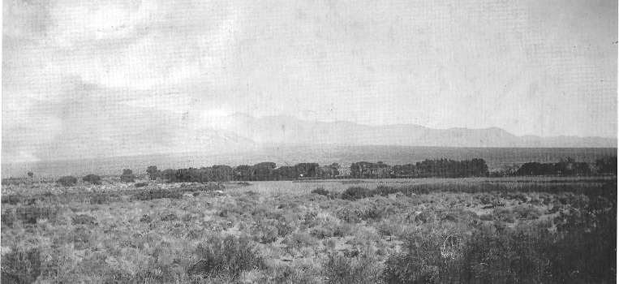

Manse Ranch

GATEWAY TO THE FUTURE

Robert D. McCracken

Nye County Press
TONOPAH, NEVADA

Manse Ranch
by Robert D. McCracken

Published in 2009 by Nye County Press
P.O. Box 153
Tonopah, Nevada 89049

© Copyright 2009 by Nye County Press
All rights reserved. No part of this publication may be reproduced or transmitted in any form or by any means, electronic or mechanical, including photocopy, recording, or any information storage or retrieval system, without permission in writing from the publisher.

ISBN 978-1-878138-03-3

DESIGN BY JANE RAESE
Frontispiece: Manse Ranch pictured from a distance looking east-southeast, circa I goo. Photo courtesy of Joyce Yount Dangermond.

Printed in the United States of America

In appreciation for their unwavering support and encouragement for the production of this book:

NYE COUNTY COMMISSIONERS
Andrew "Butch" Borasky, vice chair
Roberta "Midge" Carver
Joni Eastley, chair
Gary Hollis
Peter Liakopoulos

and

NYE COUNTY NUCLEAR WASTE REPOSITORY PROJECT OFFICE
Darrell Lacy, director

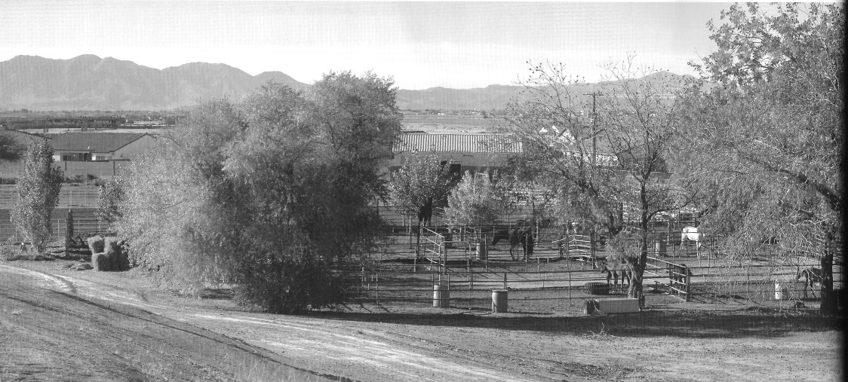
Photo of the corrals as they appear today, looking west,
December 2008 (Jeanne Sharp Howerton)

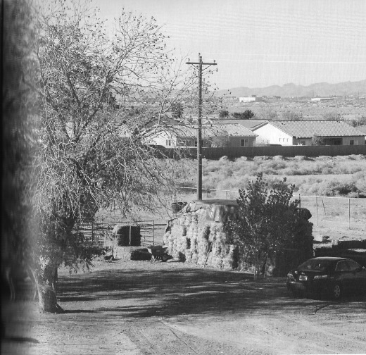
Photo of the corrals as they appear today, looking west, (2nd photo of previous page)
December 2008 (Jeanne Sharp Howerton)

CONTENTS

Acknowledgments

Preface

Introduction

PHOTOGRAPHS
The Younts

The Whites

Ranch Life

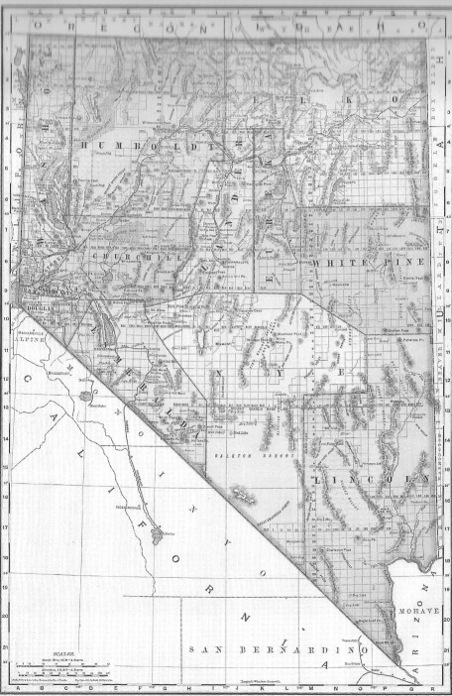
Nevada, 1893, Rand, McNally, and Company. Nye County is enlarged next photo. Pahrump and Manse are shown in the southeast corner of Nye County, with Manse circled.

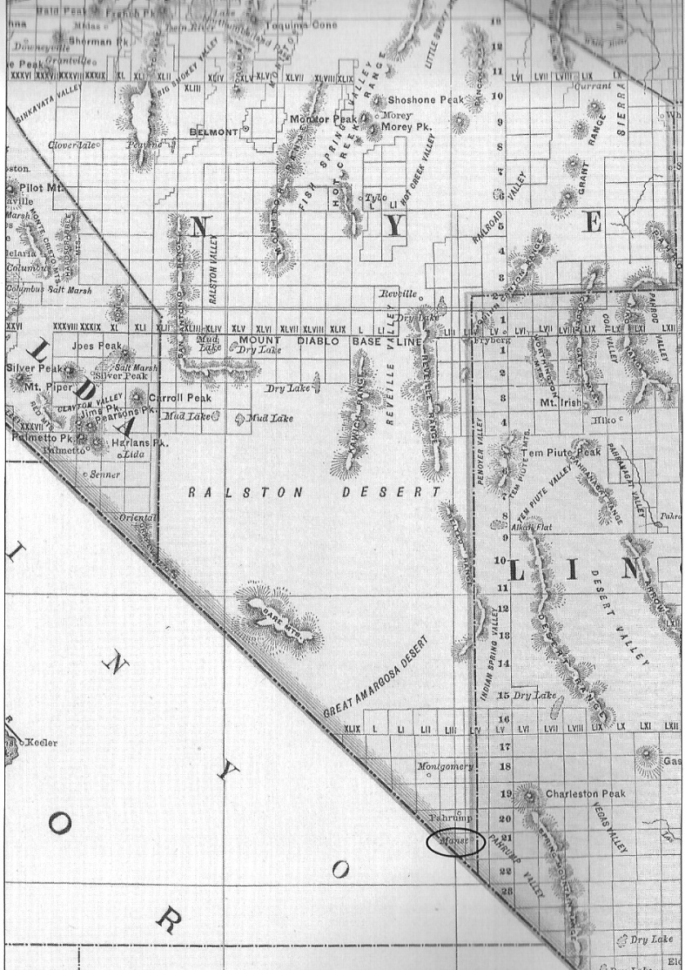

ACKNOWLEDGMENTS

This volume was produced as part of the Nye County Town I History Project, initiated by the Nye County Board of Commissioners, Nye County, Nevada, in 1987. Board members approved funds for t he creation of this book in the fall of 2008. Our deepest appreciation is goes to Commissioners Joni Eastley, chair; Andrew Borasky, vice chair; Roberta "Midge" Carver; Gary Hollis; and Peter Liakopoulos; and to the director of the Nye County Nuclear Waste Repository Project Office, Darrell Lacy. Without their support, this book would have remained only a dream.
Harry Ford, founder of the Pahrump Valley Museum, was a constant source of help and inspiration in the writing of this book. Rob Mobley and David Peel, associates at the museum, provided much-appreciated encouragement and were helpful with needed research. Eva La Rue and Angela Haag of the Central Nevada M scum in Tonopah helped with research in old newspapers. Peter Michel, director of Special Collections, University Libraries, UNLV, provided helpful research support.
Joyce Yount Dangermond, a great-granddaughter of Margaret and Joseph Yount, provided the majority of the photographs in this book. She and her husband, Allen, also shared essential information, both written and verbal, on Yount family history. Without the Dangermonds' contributions, we would have no book. Dr. James Ferguson, a great-great-grandson of Margaret and Joseph, contributed a substantial number of photographs and helped identify them. Michele Nielson, archivist and historian at the San Bernardino County Museum, San Bernardino, California, provided additional pictures reproduced here and helped to identify and date many photos.
Joyce Yount Dangermond, Joni Eastley, Don Hendricks, Jeanne Sharp Howerton, and Harry Ford critiqued several drafts of the manuscript for this volume. Joyce Yount Dangermond was essentially on call for months, carefully answering questions that came up regarding the Yount family. In addition to help with the manuscript, Joni Eastley advised on book design and production problems as work progressed. Jeanne Sharp Howerton scanned all the photographs in the book and took the contemporary shots of the Manse Ranch site, including the beautiful color photos. Don Hendricks was helpful with research and in sorting through the many facts, some of them contradictory, that comprise the Yount family history. Harry Ford critiqued the manuscript and photo captions and was always helpful in piecing together this important part of Pahrump Valley history.
Laraine Crowther and her brother Gary Bowman, current manager of the Manse Ranch site, are grandchildren of Elmer Bowman, who purchased the Manse Ranch in 1946. They provided a guided tour of the ranch site in early December 2008, at which time the contemporary photos were taken.
Jean Charney and Kimberly Dickey transcribed several drafts of the manuscript and photo captions. Michelle Starika Asakawa edited the book and selected the order in which the photos appear. Jane Raese designed this book and its dust jacket.
I would like to express my deepest appreciation to all these people for their efforts in producing this book. It has truly been a team effort. Any errors or deficiencies are, of course, the author's responsibility. - Robert McCracken - October 2009
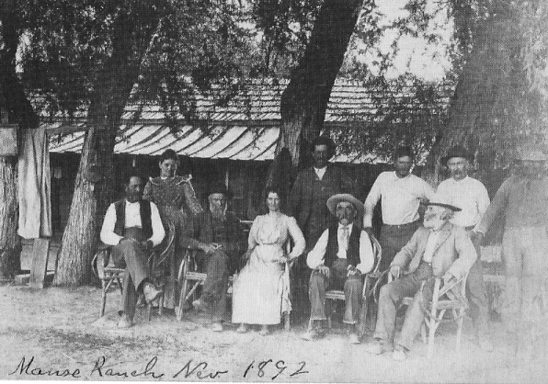
Manse Ranch, 1892. Photo courtesy of Dr. James Ferguson.

PREFACE

In 1876, southern Nevada was very much a desolate and wide-open place. Within this vast domain Native Americans reigned supreme, as they had for the previous 13,000 years or more. The Mormon Fort in the Las Vegas Valley was founded in 1855, but its occupation by its builders lasted only two years. The Comstock's fabulous deposit of silver and gold, located on the eastern flank of Mount Davidson in the Washoe Mountains in northern Nevada, was discovered in 1859. Discoveries in El Dorado Canyon on the Colorado River date to 1861. The silver at Austin was discovered in 1862, and Reveille in the Reveille Range was founded in 1866. Hiko in the Pahranagat Valley dates to the late 1860s. The settlement of Goodsprings dates to 1868. Towns west of Pahrump Valley such as Resting Springs and Tecopa date to the mid-1870s. Octavius Decatur Gass took over the Mormon Fort site in the Las Vegas Valley in 1865, and Helen and Archibald Stewart did not take up residence there until 1886. This was the context in which a family from Oregon found itself in the fall of 1876.
The story of Joseph and Margaret Yount and their family's settling of the southern Nevada desert in Pahrump Valley is one of the most interesting and inspiring in the history of the American West. Joseph Yount was a true man of the West. He had served in the Mexican War in 1846-1817, was active in the California and Colorado gold rushes, and was captain of a train of 100 covered wagons that traveled from Nebraska to northeastern Oregon in
1860. Alter Spending fourteen years in Oregon, during which time he and Margaret helped found a community in the Grande Ronde Valley area, Yount and his family decided to move to Arizona, where they had heard land and opportunities were abundant. With eight children ranging in age from a few months to eighteen years, a married daughter and her husband and their child, and another family, they set out for Arizona, traveling by covered wagon and pushing at least 200 head of cattle.
The Younts never reached Arizona. Fate intervened, and they were forced to settle at the Manse Springs in Pahrump Valley, Nevada. The only improvement at the site of their new home was a crude dirt-floor dwelling measuring about 1 2 feet by 15 feet and made of brush and mud. With a true pioneering spirit and willingness for hard work, within a few years the Yount family had transformed what fate had handed them into a southern Nevada showplace. At the Manse Springs, the Yount family literally made the desert bloom. The beginning of the town of Pahrump, Nevada—indeed, the real beginning of Euroamerican civilization in the region, including the Las Vegas Valley—can be traced to the Younts' accomplishments at the Manse Ranch.
Although other Euro-Americans had preceded the Younts to what became southern Nevada, none made the sustained multi-decade commitment to develop the region's many resources that the Younts did. Rather, their attention was focused on a single resource, usually either mining or agriculture, for a relatively short period of time, with most soon moving on to greener pastures. So far as I know, the Younts were the first in the area to make a real effort to promote the region's overall economic potential with the hope that others would join them and contribute to building a community on the frontier. The Yount family members pointed with pride to their accomplishments on the ranch and to their efforts in mining and the timber business as if to proclaim, "Others can do what we have done."
Sonic time around t 89o, someone in the Yount family or an acquaintance with connections to the ranch acquired a high quality camera. Over the next twenty years or so, many high-resolution photographs of the ranch and life there were taken. We don't know how many photographs there were in total, but the number was probably rather large. The Younts' daughter Maude and her husband, Harsha White, sold the ranch in 1910 and moved to San Bernardino, California, where many of the Yount family members had previously moved, including Joseph and Margaret Yount.
There are two chains of possession of the Manse Ranch photo-graphs taken between about 1890 and 19 10. With the first, we know that at some point after the ranch was sold by the Yount family in 191o, John Yount, oldest son of Margaret and Joseph's fifth child, Leroy Oliver, came into possession of a set of the photos. John lived in Redlands, near San Bernardino, California. He kept the photos, along with a small assortment of documents regarding family history, in an adobe outbuilding near his home that he used as an office and for storage. John had no children, and upon his passing, family members retrieved his stored possessions. Unfortunately, they found that rodents and insects had invaded the archival treasure and destroyed about 25 percent of it.
In the 198os, Joyce Yount Dangermond, John Yount's niece, came into possession of the salvaged archive. The majority of the photos reproduced in this volume, as well as much of the information in the text and photo captions, are from that source. Joyce Yount Dangermond has generously allowed these photographs to be reproduced in this book.
In the meantime, Dr. James Ferguson, great-great grandson of Joseph and Margaret Yount and great-grandson of the Younts' third child, Joanna Yount Gardner, came into possession of a set of the Yount photos that had been passed down over the decades from his great-grandmother. There is some overlap in his photo archive with Joyce Yount Dangermond's, but much of it is unique. Dr. Ferguson has kindly granted permission to include a significant number of photos from his archive in this volume and has helped to identify them,
The story of the founding of the Manse Ranch and of the lives of Margaret and Joseph and their children now lies more than a century in the past. Information provided by the principals is thin; apparently none of the Yount family members kept diaries or were frequent letter writers. (A few excerpts from letters that. Harsha White wrote to Nye County officials are quoted in newspaper articles from that period.) Thus, the historian at this point is forced to rely largely on a few written documents and sporadic items from newspapers of the time (beginning in the 18gos). The basic outline of the lives of the Yount family members and their building of a life in Nevada is solid. At times, however, details of the story as they have come down to us are inconsistent. We have attempted to address some of the inconsistencies in footnotes in this book's introduction.
Given additional time and resources, more can be done to amplify our understanding of the Manse/Yount story. We hope this book will help inspire more research on this wonderful account of how a family founded a community on the southern Nevada desert and, in doing so, beautifully exhibited the true spirit that lay behind the founding of America.

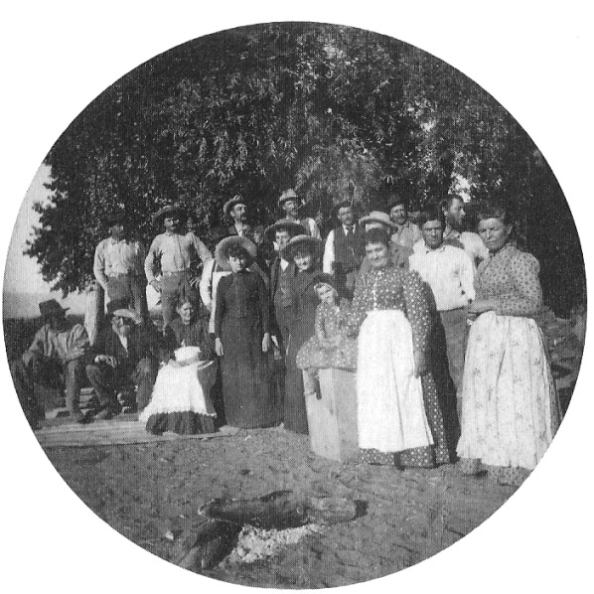
Group picture at Manse Ranch, also called White's Ranch at the time, 1898. Perhaps Maude Yount White standing in front with white apron. Photo was taken the same year that Joseph Yount, then eighty years old, moved to San Bernardino, California. Photo courtesy of Dr. James Ferguson.

Manse Ranch

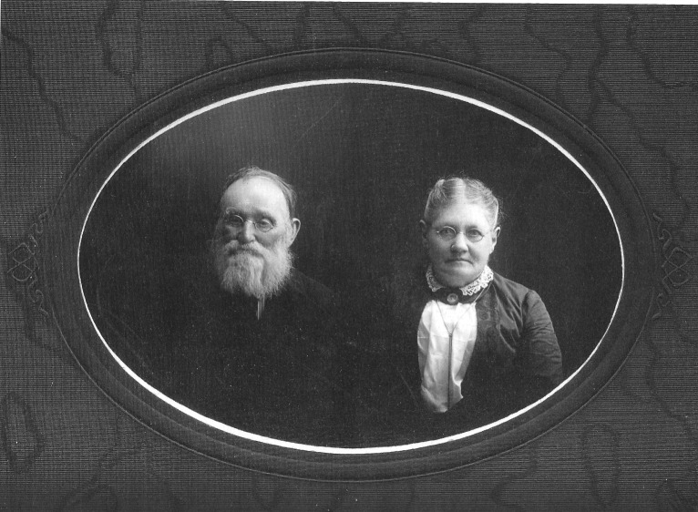
Joseph Young and Margaret Parent Yount, 1905
Photo courtesy of Joyce Yount Dangermond.

INTRODUCTION
The story of the development of the Manse Ranch—beginning in 1876 in Pahrump Valley in southern Nye County, Nevada—is one of the most inspiring in Western American history. Though not widely known, it embodies all that is great in American civilization, including extraordinary courage, willingness to work hard and face hardship, and a can-do attitude embodying the belief that a most inhospitable environment can be made to bear in abundance civilization's fruits. Joseph and Margaret Yount and their daughter and son-in-law, Maude and Harsha White, founders of the Manse Ranch, reside at the heart of this inspiring story and are deserving of our greatest respect and admiration.

BACKGROUND

The Nevada Territory was created in 1861, and the state of Nevada was admitted to the Union in 1864. Nye County was created that same year, with its present boundaries encompassing 18,294 square miles finalized in 1875. The region features classic basin¬and-range topography, with alternating north-south trending mountain ranges, some rising to heights above 11,000 feet, separated by valleys 10 to 30 miles wide. Cold winters and warm summers with moderate yearly precipitation give way, north to south, to mild winters and hot summers.
About 20 miles wide and 7o miles long, Pahrump Valley is located at the far southern end of Nye County. Its western margin is defined by the Nopah and Kingston ranges, whose highest points are Nopah Peak, at 6,395 feet, and Kingston Peak, at 7,323 feet. Its eastern margin is defined by the rugged and magnificent Spring Mountains, whose highest point is Mount Charleston, at 11,915 feet. The valley floor averages less than 3,000 feet in elevation. Average yearly precipitation in the valley is about five inches, mostly in rainfall. Rain and heavy winter snow in the Spring Mountains provide 20,000 to 30,000 acre feet of recharge yearly to the aquifer beneath Pahrump Valley. The modern community of Pahrump (estimated 2009 population 39,000), the valley's only town, is located at the north end.
Pahrump Valley's history, as with all the American West, has been defined by the availability of water. Until recent years, three great springs flowed in Pahrump Valley, along with a number of small springs and seeps. The largest was the Pahrump Spring. Though it is now dry, in 1946 it was estimated to have produced about 4,40o acre feet of water annually. It was located just southwest of the intersection of present-day State Highways 160 and 372. The Pahrump Spring was the basis of the giant Pahrump Ranch, the largest of the two big ranches in the valley. The other two large springs were located 6 miles south of Pahrump Spring. Known as the Manse Springs, and separated by no more than loo feet, both continue to flow today. Combined, they produce about 3,000 acre feet of water per year. Groundwater in the valley is relatively accessible, often lying no more than 5o feet below the surface.

EARLY OCCUPANTS AND EXPLORATION

Pahrump Valley's three big springs ',And their resources were a center for Native American life in the valley beginning with the first arrival or human beings in the area more than 3,00o years ago.
The Southern Paiutes, a culture based on hunting and gathering, occupied the Pahrump Valley when Euro-Americans are known to have first entered the area in the 182os. Canadian trapper and explorer Peter Skene Ogden may have been the first person of European ancestry to set foot in Pahrump Valley: in 1828 he entered present-day Nevada from the north and traveled south from the Carson Sink area east of present-day Reno past Walker Lake to the Gulf of California, paralleling the present California-Nevada border.
The Spanish Trail crossed Pahrump Valley at Stump Springs, and beginning in 183o thousands of travelers and untold numbers of livestock traversed the route between Southern California and points east. In late April 1844, John C. Fremont and his exploration party were headed from Southern California toward the Las Vegas Valley when expedition members Alex Godey and Kit Carson had a deadly encounter with local Native Americans in the Kingston Range at Horse Thief Springs.
In 1871 a detachment from George M. Wheeler's U.S. Army Corps of Engineers exploration expedition, under command of Second Lieutenant D. A. Lyle, traveled from Belmont to Stump Springs in Pahrump Valley. Lyle described Pahrump Valley as follows: "This desert contains several beautiful oases, the principal one being at Pahrump Springs, at which point are located quite a number of Pah-Ute Indians, very friendly and quite intelligent. These Indians raise corn, melons, and squashes. Great quantities of wild grapes were found around these springs" (Wheeler, 1872:84).

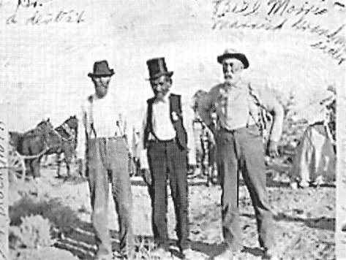
The back of the photo reads: "Dr. Blackburn, ChielTecopa (Wildcat) in the middle, and Uncle. Rill Morris [perhaps Margaret Yount's brother-in-law on the right] Perhaps taken the Manse Ranch, circa 1900, Photo courtesy Joyce Yount Dangermond

CHIEF TECOPA AND SON

Cheif Tecopa, a Southern was the most important Native American in the Pahrump Valley area in the last half of the nineteenth century. He was the pakwinavi, the "leader" or "head man" of the Paiutes in the Pahrump area, including the villages of Tecopa, the largest in the area; moqua in the Kingston Range at Horse thief springs; Nogwa at Potosi Spring; and Pahrump Spring. Richard Lingernfelter in his wonderful book, Death Valley and the Amargosa: Land of Illusion (1986),writes that Tecopa's name is derived from the Southern Paiute term tecopa, meaning "wildcat," but "was an inadequate description for so shrewd and skillful a negotiator as he. The whites imagined that his influence extended all the way from Death Valley to the Colorado River, and he did nothing to discourage the notion. They plied him with gifts, including his favorite stove pipe hat, and named a mining camp after him, all to win his aid and blessings in prospecting the surrounding country" (p. 22). This perception of Chief Tecopa's standing by the whites, Lingenfelter writes, acted as a self-fulfilling prophecy for his influence.
In the late 186os a Paiute named Mormon Charlie, said to be a progressive, started a stock-raising ranch at Manse Springs, using stock left over from the Potosi mining boom, which had lasted for four years beginning in 1861. Mormon Charlie's ranch is listed on Wheeler's 1873 map of the Pahrump Valley area. Pahrump Spring is also located on Wheeler's map, but not as a ranch. Thus, Mormon Charlie's ranch at Manse Springs was the first known in Pahrump Valley. Mormon Charlie's ranch was taken over by the Jordan brothers in 1876 (Lingenfelter, 1986: 162, 167). The Jordan brothers—sources differ as to whether there were two or three brothers—who may have been Mormons, constructed a small but made of poles, brush, and mud and attempted to cultivate a small area near the springs. But they did not stay long; in less than a year, they sold out.
In the meantime, by 1875 Chief Tecopa had established a rancheria at the Raycraft Spring, located about a half-mile north of Pahrump Spring.' In that year, a man named Charles Bennett and his wife moved onto Pahrump Spring. In 1882 Bennett sold his ranch for $20,000 to Aaron and Rosie Winters. The Winters had acquired the money for the purchase through the sale of their borax claims, located a few miles north of Furnace Creek in Death Valley, to borax magnate William T. Coleman.

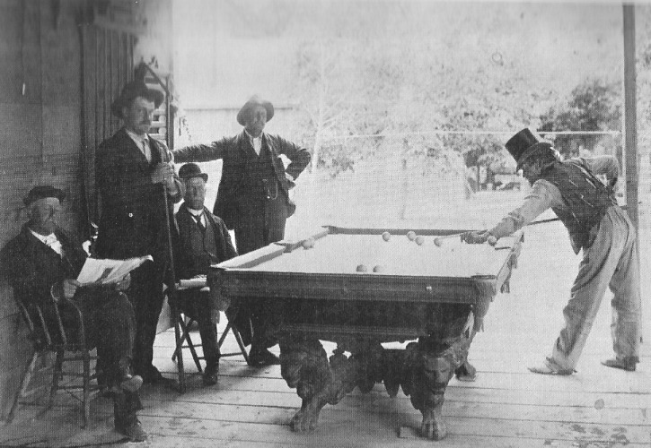
Outdoor billiards game with Chief Tecopa (wearing tall hat). Sam Yount is pictured at far left; others not identified. Probably taken in Goodsprings, Nevada, circa 1895. Photo courtesy of Joyce Yount Dangermond.

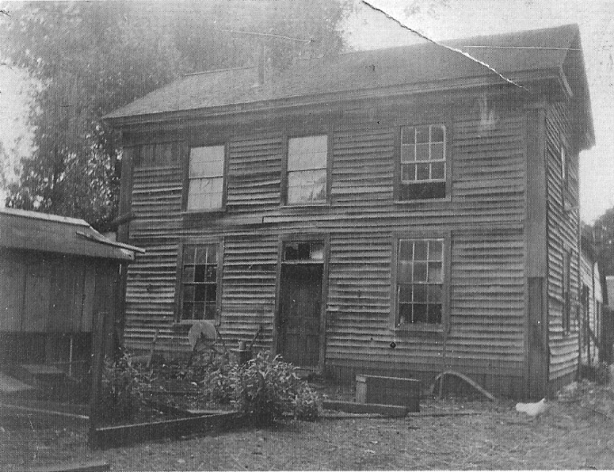
The home of the Yount family near La Grande, Oregon. They lived in this house prior to leaving Oregon in 1876. It is possible that Joseph Yount built it. Undated. Photo courtesy of Joyce Yount Dangermond.

JOSEPH AND MARGARET YOUNT

Although there is obviously some room for disagreement, I trace the true beginnings of Euro-American settlement in the Pahrump Valley, and thus the origins of the town of Pahrump, to the arrival of Joseph and Margaret Yount and their family in the winter of 1876-1877. True, Bennett and his family and the Jordan brothers preceded the Younts by a year or so, and Mormon Charlie, John, and Chief Tecopa had small ranching operations, but, unlike the Younts, none of these people made a sustained commitment to developing the valley's potential.
Joseph Yount was born March 2, 1818, in Howard County, Missouri, where as his obituary said, "he grew to manhood" (Las Vegas Age, January 12, 1907). He was mustered into the U.S. Army on June 16, 1846, at Fort Leavenworth, Kansas, and became a member of Captain M. M. Parson's Company F, First Regiment, Missouri Volunteers. Company F served with General Alexander W. Doniphan in the Mexican War in operations from El Paso, Texas, to Monterey, Mexico, sometimes defeating opposing forces many times its size. 2 At the end of his twelve-month enlistment in the army, Joseph Yount was discharged in New Orleans, Louisiana, on June 21, 1847. At that point, he traveled to San Francisco, California, being there shortly before James W. Marshall's discovery of gold in January 1848 on the South Fork of the American River, about 40 miles northeast of Sacramento. During his visit to San Francisco, Yount is reported to have "suffered many privations, even wrapping his feet with gunny sacks to protect them from the cobble stones with which the streets were paved." I le is said to have returned home by way of Cape I loin. Following Marshall's discovery, Yount went back to California in 1849, and this time Dame Fortune smiled on him. Don Hendricks notes that the 185o U.S. Census finds Yount in Trinity in the California gold country. Yount returned to Missouri in 1852 after having acquired a "respectable stake" in gold mining (Brown and Boyd, 1922:1146). 3
Little is known of Joseph's wife, Margaret E. Parent Yount. She was born August 28, 1834, in Holt County, Missouri, making her sixteen years her husband's junior. At age nineteen, in 1853, she married Joseph Yount. She moved to Nevada in the winter of 1876-1877 and relocated to San Bernardino, California, at some point after 1886, where she remained until her death in 1912.4 Margaret was the mother of ten children, all of whom lived to maturity, and is described as having a "genial and hospitable disposition." She is best remembered as a pioneering woman and a loving mother. Her obituary states, "None knew her but loved her; none named her but to praise."
According to Joseph Yount's obituary, he and Margaret moved from Missouri to Richardson County in southeastern Nebraska in 1856. In 1858 Joseph served as a guide to the gold rush at Pikes Peak, Colorado, and he stayed in the Front Range area of Colorado for about eight months before returning to Nebraska. The family remained in Nebraska until 1862, at which time Yount was chosen to captain a train of 10o wagons bound for the La Grande area in northeastern Oregon. By this time, Joseph and Margaret had five children—three girls as well as twin boys born the year they left Nebraska. The family traveled to Oregon in a covered wagon pulled by a team of oxen. In Oregon, the Younts are thought to have helped found the town of Summerville in the La Grande area.5
In Oregon the Younts farmed and raised cattle and appear to have flourished. However, in 1876 they sold their holdings, and with wagons, draft and riding horses, between 100 and 200 head of cattle, and with at least eight unmarried children ranging in age from newborn to eighteen, they headed for Tombstone, Arizona,

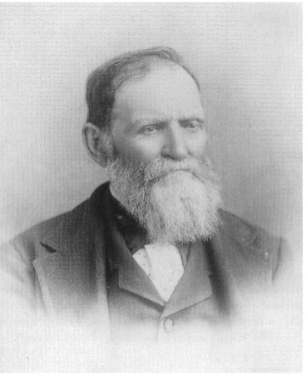
Joseph Yount, circa 1895. Photo courtesy of San Bernardino County Museum.

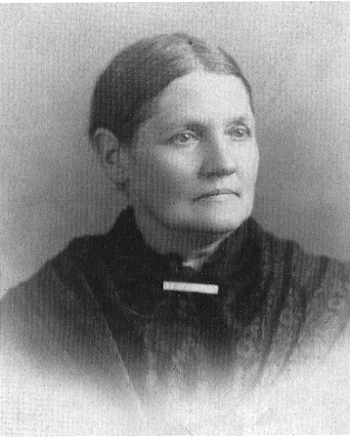
Margaret Parent Yount, circa 1895. Photo courtesy of Joyce Yount Dangermond.

The Younts had heard of great opportunity in Arizona, with news of unlimited availability of land. They intended to sell all or part of their cattle in Tombstone. They were joined in the move by their second-oldest daughter, Maude, and her husband, Harsha White. It is not clear whether their oldest daughter, Laura, who would have been twenty-two, accompanied them. Before leaving Oregon, the Younts were joined by C. W. Towner and his wife and their two children, adding their wagon (s) and 10o head of cattle to the outfit.
The Yount family is thought to have had two covered wagons, with Joseph and Margaret driving one and their twin sons, William and Thomas, who were but fourteen years old, driving the other. The Whites added two covered wagons containing all their household goods in addition to a pregnant milk cow to the wagon train headed for Arizona. Sam and Lee, ages eleven and nine years, rode horseback tending a herd of perhaps as many as 30o head of cattle. They moved out ahead of the wagons, questioning people along the way as to the availability of water. They often relied on their riding horses' ability to smell water ahead and lead them to it.
Drought may have been the precipitating factor in the Younts' decision to leave Oregon. A document written by Joseph and Margaret's great-granddaughter, Joyce Yount Dangermond, keeper of the Yount family archive, states that in about 1876 a drought hit Southern California and all but ended the cattle industry there. Conditions were also reportedly dry in the La Grande area.6
Harsha White was born May 23, 1850, in Lawrence County, Pennsylvania. He moved with his parents to Missouri at an early age. Overcoming many obstacles, he graduated from the University of Missouri when he was seventeen. At the age of twenty, White traveled to Oregon by stagecoach, going by way of Salt Lake City, and settled in Summerville, Oregon, in the Grand Round Valley. His obituary (from an unidentified, undated newspaper obituary in the Fisk file at the San Bernardino County Museum that likely appeared in the Las Vegas Age in1923) says, "Owing to his superior education, his services were much in demand as a teacher." White taught several terms at the famous Saw Buck district in Oregon. He met and married Maude Yount in 1872.
White's obituary states that he accumulated "a considerable fortune ranching and mining and became one of the principle owners of the Boss Mine and [owned] considerable stock in the famous Yellow Pine Mine at Goodsprings." He is said to have retired from active business in 1909 and moved to Los Angeles, California, where he died in 1923. In 1905 he was described as having been "the moving spirit at the Manse" (Las Vegas Age, September 3o, 1905). His obituary described him as "one of God's noblemen . . . one of the foremost men in the early building of Southern Nevada. He was ever charitable, public spirited and loyal to friends, loved and respected by all." White was a prominent Mason, a member of the Las Vegas Lodge, and "a true Elk." The Harsha White–Maude B. Yount union produced two children—Edward, who died in infancy, and Della.

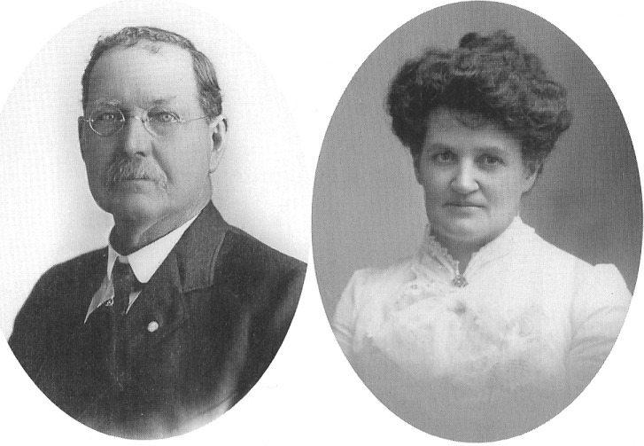
Harsha White and Maude White, circa 1900.
Photos courtesy of San Bernardino County Museum.

FROM OREGON TO NEVADA

The first part of the Yount party's trip from Oregon to Arizona was difficult but without serious known adversity. The travelers arrived at the Pahranagat Valley in Lincoln County, Nevada, in late October 1876. During their first night there, cattle rustlers stole about fifty head of cattle, and it took the riders several days to track the cattle and get them back. The thieves were never found. With winter coming on fast, Harsha and Maude White decided to remain in the community of Hiko in Lincoln County, where Maude (not Harsha) took a teaching job. The plan was for Harsha, Maude, and baby Della, who was but sixteen months old, to meet up with the Younts the next spring.
The Yount and Towner families, absent the Whites, left the Pahranagat Valley in late November I 876. It took them two days to cover the 4o miles to the Groom Mine. Three more days' journey, without water, was required to get to Indian Springs, 6o miles away, and after two more days they reached Ash Meadows, Nevada.
C. W. Towner and his family had chosen to stay in Indian Springs. Towner traded (presumably cows) for a ranch belonging to a man named Andy Laswel1.7 It is not clear why the Towners settled at Indian Springs and whether that had been their plan all along. If it had not been their plan, why did they quit? Perhaps they found what they were looking for, as Harry Ford said. They raised vegetables and produce at Indian Springs and sold them to miners at El Dorado Canyon. For years, their nearest neighbors were said to be 40 miles distant (Beatty Bullfrog Miner, November 11, 1905).
Towner wasn't the only one who appears to have deviated from his original plan. According to John Doherty (1974:166), at some point the Younts had apparently changed their minds about going to Arizona and had decided to head for Southern California in¬stead.8
At Ash Meadows the Younts stopped at a "small, common, poor ranch owned by a farmer from Missouri" by the name of Bell. Bell offered the travelers such amenities as he had. Yount noticed there were Indians riding in the vicinity of Ash Meadows, but Bell assured him there would be no problems and that they were neighborly. There was good grazing for the herd near Bell's place. White's cow was getting ready to calf, and the Younts decided to rest there. The boys took the draft horses, along with the saddle horses and at least two mules, into the hills in the Mount Sterling area to the east of what later became Johnnie to let them graze on the bunch grass that grew in abundance there.
In the meantime, the travelers had been without flour for two weeks. Yount asked Bell if he had flour available for purchase. Bell replied Mat he ILO none. Yount, intent on obtaining this commodity, set out for one of the mining camps in the Death Valley area I() the west, perhaps Tecopa, He was able In purchase' Only 25 pounds.
John Yount, who was four years old at the time, later recalled how, upon their father's return to Ash Meadows with the flour, Margaret set to baking and got all the children up in the middle of the night to feed them hot rolls.
After Joseph Yount's return with the flour, he and one of his fourteen-year-old twins headed into the mountains to collect their horses. After covering a number of miles they found a suitable place to spend the night. The next morning they traveled up a canyon where they had tracked them. To their horror, they found one horse after another dead, killed by arrows. They soon discovered that all of the horses that had been turned out to graze that carried the mark of the collar on their necks had been killed by Indians. Two saddle horses whose manes had been trimmed were also shot. The saddle horses with full manes had been spared.'
The Indians also shot two mules with arrows, killing one. Yount removed the arrows from the other mule, who recovered and lived a long life. But ever after, the mule, understandably, was said to be afraid of bows and arrows.
Yount soon learned that the renegade Paiute Horseshootem was behind the criminal acts. Bell offered an explanation for the Indians' behavior: "The Indians wanted the white men to settle in the valley because it would have been an easier life doing work for the whites than living their traditional life." There isn't much evidence one way or another for this explanation. Historian Burr Belden offered another reason for the Indians' actions. Years later, he says, after the Indians had become comfortable with the Yount family's presence in the valley, often living nearby and working on the ranch, the Indian women confided in the Younts. They said the workhorses had been killed so the travelers could not go on but would be forced to remain in the area. With all those cattle and horses stranded there, the Indians figured they could be picked off as needed For 100(1 (Belden, 1957).

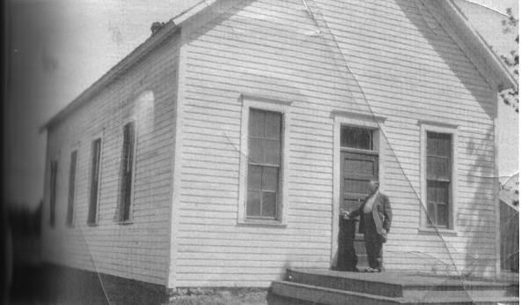
Schoolhouse in La Grande, Oregon, area, perhaps near Somerville, constructed in .about 1866. Harsha White is believed to have taught here with the school aged Yount children in attendance before the family left Oregon. Undated. photo courtesy of Joyce Yount Dangermond.

Jospeph and Margaret, of course, recognized that they were in deep trouble, Stuck in middle of nowhere with eight children, their best option appeared to lie in trying to replace the horses that had been killed and move on. While Margaret stayed at Ash Meadows tending to the small children, Joseph rode west to Pahrump Valley. He stopped first at the Pahrump Spring, where he met Charles Bennett, his wife, and two children.' Yount asked Bennett if he had horses for sale or trade. Bennett replied he had none, but he informed Yount that he might be able to trade for a farm located 6 miles to the south owned by three brothers named Jordan.12 The brothers were Mormons, Bennett said, and were interested in returning to Salt Lake City.
Yount rode to the Jordans' place and described his predicament to the owners. After some discussion, he traded the brothers 1 oo head of longhorn cattle for their holdings at Manse Springs. When Yount traded for Manse Ranch, he believed it was located in Lincoln County, but a survey later proved that it was in Nye County by half a mile. This was prior to Clark County being carved out of Lincoln County in 1908.
The Yount family moved onto what became the Manse Ranch in the winter of 1876-1877. To say the place was underdeveloped would be an understatement. Aside from two magnificent springs and the vegetation that grew around them, the only structure was a house amounting to little more than a wickiup 12 x 15 feet in dimension. It consisted of posts driven into the ground with brush strung between the poles and then plastered with mud. The roof was also constructed of poles, brush, and mud, and the interior featured a dirt floor. The ten Yount family members spent the remainder of the winter there. Years later Della Fisk, a granddaughter of Joseph and Margaret, recalled family members saying that "when it rained outside, it rained inside" their first home at the Manse Springs.
In order to begin cultivating the land at the Manse Springs, the Yount boys broke. the saddle horses to harness. According to documents found at John Yount's place alter his death in 1981, "the fist winter was a hard one." Margaret and the older girls made clothing. "Men's pants were made from wagon canvas and moccasins from tanned hides of deer and mountain sheep, which the boys brought in from the adjacent mountain." As soon as the weather was suitable, every hand was put to work putting in crops and making gardens with seeds brought from Oregon. The soil was productive, and the crops prospered. A good yield was available by summer, with plenty of watermelon and corn. The Tecopa Mine, located 3o miles away, provided a thriving market for the Younts' products. The miners were willing to pay about any price they asked. The cattle did well on the range.

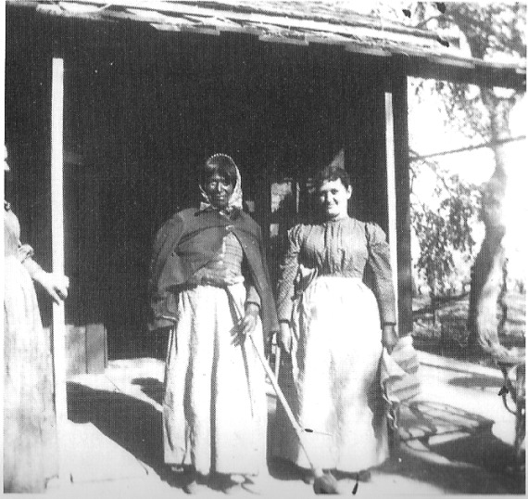
Unidentified Native American woman and (probably) Maude Yount White, circa 1890's. Photo courtesy of Joyce Yount Dangermond.

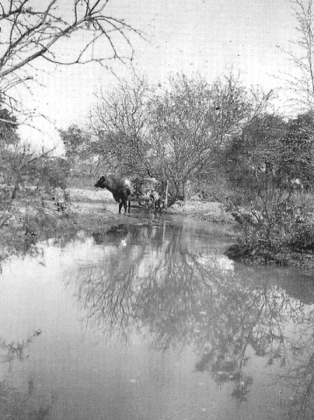
A pond formed on the Manse Ranch by one of the two big free flowing springs, circa 1900. A Yount milk cow is pictured. Photo courtesy of Joyce Yount Dangermond.

The family made enough money in the summer of 1877 to buy sufficient food and clothing for the next winter. That first summer, they also constructed a second dwelling. Because he had fodder from his corn crop, Joseph Yount built the frame of mesquite limbs with fodder strung between the posts. He then laid stalks against the sides and plastered it over with mud. He built the roof in the same way. His new construction was about 20 feet square, with one door and one window. Because the stalks were an obvious fire hazard, no one was allowed to use candles or any flames for light. The family lived in that building all of winter 1877-1878 and the next spring. Late that winter Joseph made a 200-mile trip to San Bernardino, California, where he had purchased nursery stock sufficient to plant a to-acre orchard. His purchase was almost entirely paid off by the proceeds of a bumper crop of watermelons, which the boys sold to local miners. In 1878 the Younts constructed an adobe brick building 20 X 40 feet in dimension, consisting of two big rooms and a porch all the way around. It made a fine home, cool in the summer and warm in the winter.
Though primarily a cattleman, Yount was a skilled agriculturalist. His hay crop thrived, and he was one of the first settlers to plant alfalfa in the valley. Soon Yount was producing a surplus of hay. According to Belden, there was a good market for this surplus. Lingenfelter (p. 169) writes that a grower could get four cuttings of alfalfa per year in the Amargosa region, yielding six ton per acre. Hay was worth $70 to $20o per ton in the surrounding mining camps. The Younts hauled the hay to Marvel and Vanderbilt and to San Bernardino County. Two big wagons stacked high with hay pulled by eight to ten horses made deliveries between the ranch and mining towns in the region. One year, after the Rhyolite boom began, all the Younts' hay was sold at Beatty and Rhyolite.
When the Las Vegas & Tonopah and the Tonopah & Tidewater railroads were constructed, horse teams pulled Fresno scrapers to grade the roadbeds. Burr Belden notes that the builders of the railroads in Nye County in 1907 "burned" hay rather than coal and oil. Some of that hay came from the Manse Ranch.
The Younts grew a variety of vegetables that brought over $200 per ton, with fruit and nuts bringing over S5oo per ton. On one trip to Las Vegas, Yount returned with grape cuttings in his saddlebags. He proved to be a good vintner. With 2.5 acres in seven varieties of grapes, his "Chateau Manse" was said to be superior to California's finest (Lingenfelter, 1986:169).

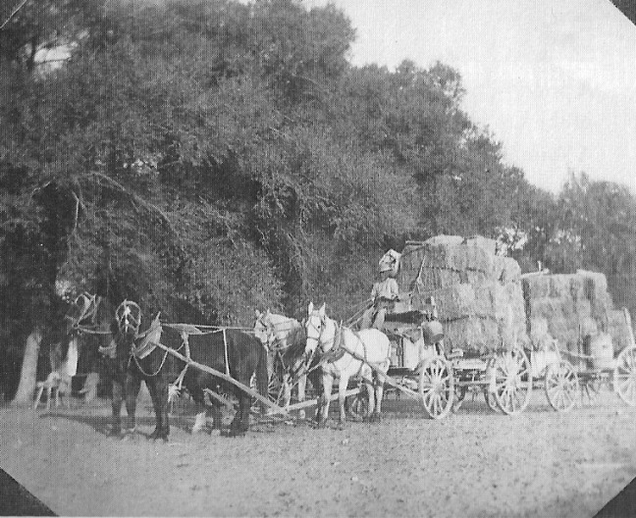
Two wagons loaded with hay pulled by four horses; workers unidentified. manse Ranch, circa 1900. Photo courtesy of Joyce Yount Dangermond.

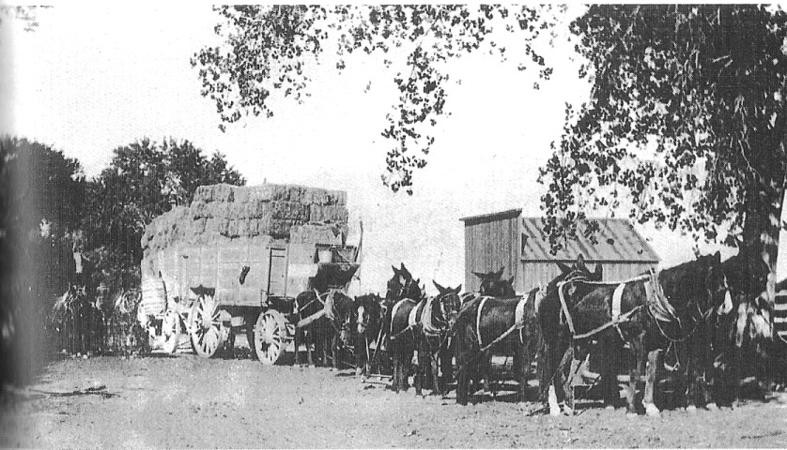
At least ten horses pulling two wagons loaded with Manse Ranch hay, circa 1900. Photo courtesy of Joyce Yount Dangermond.

Yount also acquired timber rights in the Spring Mountains and set up a sawmill. He sold his sawed timber to area miners for underground timbering and mill construction. The head frame at the Gold-Bronze Mine in Vanderbilt used lumber from Yount's mill. His lumber was also used for the construction of housing and businesses in the region. Earp's Hall in Vanderbilt, owned and run by Virgil Earp of Tombstone fame, was built with Yount lumber.
Yount, and later Harsha White, maintained their interest in lumber production in the Spring Mountains for many years. Harsha White had a partner named Nathan Clark." Clark also ran the Manse vineyard. White bought out Clark's interest in the sawmill in 1907, as reported in the Beatty Bullfrog Miner, September 23, 1905, and July 6, 1907.
In the meantime, Bennett and his family sold the Pahrump Ranch and moved, according to Joseph Yount's grandson-in-law O. J. Fisk, to Ensenada, Mexico, and ranched at the Todos Santos Hay area,
Early on, resident" end travelers alike distinguished between the Manse and Pahrump ranches. Six miles apart, they were viewed as relatively close but nevertheless separate communities. Manse had its own post office from July 5, 1891, through March 31, 1914, after which Manse mail was posted at Johnnie Harsha White was the postmaster at Manse for many years. A post office was initially established at the Pahrump Ranch on July 27, 1891, and it came and went several times over the ensuing decades.

SOCIAL SUCCESS

The Manse Ranch was, in the deepest sense, a family enterprise. Joseph Yount left the ranch in 1898 and moved to San Bernardino, where he spent the remainder of his life. He would have been almost eighty-nine years old and blind or nearly so when he died in 1907. Harsha White, who had lived on the ranch almost from its founding, became the patriarch. Harsha and Maude Yount White's contribution should be viewed at least as on a par with Joseph and Margaret Younts'.
Over the years, the Manse Ranch became a social center known and respected widely. "The White home has long been known as a hospitable retreat for prospectors and other travelers," as the Beatty Bullfrog Miner stated on November 11, 1905. A few months earlier the newspaper had reported that "Harsha White was famous all over the desert for the accommodations afforded travelers" (Beatty Bullfrog Miner, September 9, 1905).
An item in the Miner dated January 12, 1907, illustrates how the Manse Ranch became a social center for area miners. "Mineral developments around Greenwater and Johnnie have made Harsha White's famous Manse ranch the center of activity and comfort. The Manse Oasis, the great warm spring, the old farm and garden, and the hospitality of White's place are all known to desert travelers. At Manse can be had food, water and shelter for man and beast. Stages run from Amargosa to Johnnie, Manse and other points.

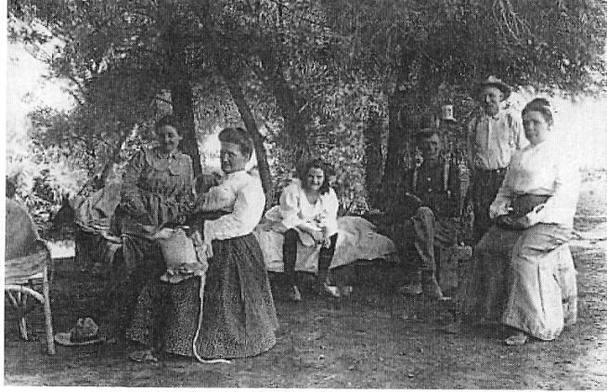
A shaded outdoor area near the main house at the Manse Ranch, circa 1900. Some family members may have used the area for sleeping. All people pictured are unidentified. Photo courtesy of Joyce Yount Dangermond.

Independence Day was an important holiday on the Western frontier. Even the smallest communities celebrated the nation's birth with _food, drink, and some kind of fireworks, if only gunfire. By the 189os, ranchers in the Las Vegas Valley were well aware of the Yount family's accomplishments in Pahrump Valley. In July 1894, fifty settlers from as far away as 100 miles gathered at the "Yount ranch home of the Harsha Whites" to celebrate the Fourth of July (Townley, 1974:4). Guests, including Helen Stewart and her children from Las Vegas Valley, began arriving on July 3. There was dancing until after midnight, when celebrants rang in the holiday with pistol shots and an anvil salute. John Yount, who was quite athletic, provided an exhibition of turning and jumping on the bar. That afternoon, national songs were sung and foot races, sack races, and egg races were held. There was a catered feast, and people danced in the evening. The next day, festivities were moved to the Pahrump Ranch, where another big meal was enjoyed. On July 6 everyone returned to their homes.

REPORTS OF YOUNT'S SUCCESS

The Yount family's success in making the desert bloom at Manse Springs did not go unnoticed. The Belmont Courier reported on June 21, 189o, no doubt referring in significant measure to success at the Manse Ranch, "sugar beets, blood beets, cabbage, rutabagas, carrots, parsnips, onions, peas, pie-plant, corn, etc., are being successfully cultivated in Nye County. . . . The wine made in Southern Nye is said, by experts, to be superior to the wine made in California, and Nye County raisins contain 2 percent more sugar than California raisins."
On May 19, 189o, the directors of the Nye County Board of Trade accepted a report from their general agent, George Nicholl, on the resources of central and southern Nye County. The board's action was described in the Belmont Courier on May 24, 1890. Nicholl quotes Harsha White in his report on conditions in extreme southern Nye County:

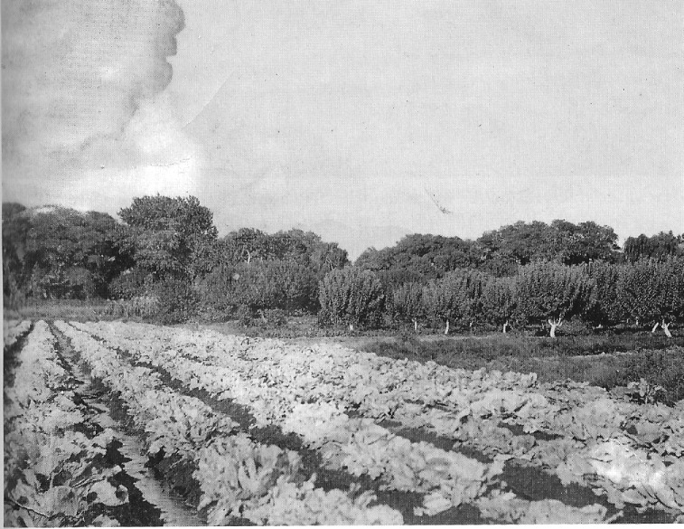
Cabbage plants and fruit trees on the Manse Ranch, circa 1900. Photo courtesy of Joyce Yount Dangermond.

"Enough has already been done in Southern Nye to establish the fact, that no better fruit, grain or hay country exists in Nevada. We are not troubled with scale or other insects to injure vines, fruit trees and growing crops, and when produced the climate is such that the fruits can be dried without loss. The fruit trees that have been tried here and yield large crops are the apple, pear, peach, apricot, nectarine, plum, almond and fig. Orange, cherry and walnut trees have been introduced in this part of Nye county and are growing fine, but not old enough to bear yet. Seven variety of grapes are doing well and yield large crops, from which we make excellent wine and raisins."
Still quoting Harsha White, Nicholl's report continues, "The soil and climate are also well adapted to the berry family. The blackberry and raspberry yield larger and finer crops than any place I've ever seen, while grain and hay yield large crops of the very best quality, and stock of all kinds are healthy and mature early."
In a letter dated April 22, 1891, George E. Crowell and Henry Metz wrote from Montgomery to Nye County Recorder and Auditor W. Brougher (Belmont Courier, May g, 1891). They tell of a trip they had recently taken across McCann Summit to Tybo and on to the Pahranagat Valley. They ended up in southern Nye County at the mining camp of Montgomery by way of the Manse Ranch. Montgomery was the predecessor of the Johnnie Mining District and was established by George Montgomery, who was searching for the Lost Breyfogle Mine in 1890 or 1891 . Of the Manse Ranch they said, "We went to White's ranch—that made us a day longer on the road. Mr. White is a very nice gentleman; he made our stay there very pleasant The wit trees on his place ere heavily lauded with Fruit—apricots the size or walnuts anti figs larger. The fig trees bear three crops a year'. It makes Hank's mouth water to think of the fruit."

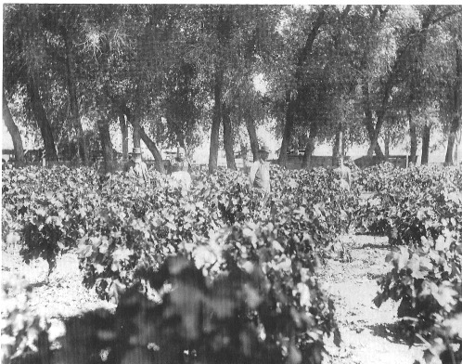
View of the vineyards on the Manse Ranch, circa 1890. Pictured are, from left, Joseph Yount, Margaret Yount, Harsha White and Maude Yount White. Photo courtesy of Dr. James Ferguson.

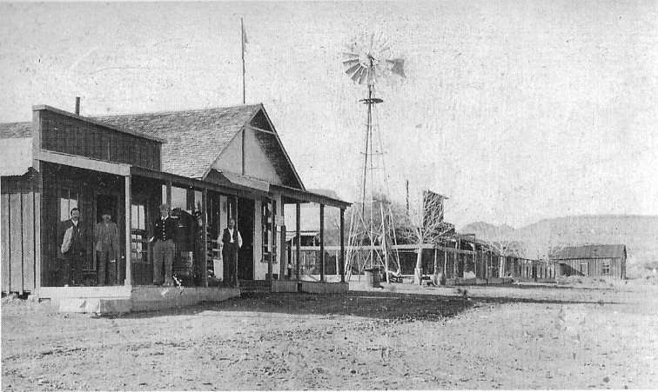
Goodsprings, Nevada, Circa 1900. A postcard photo. Inscribed on the back: "A Merry Christmas to all from Sam and Emma" - Sam Yount and his wife Emma. Photo courtesy of Joyce Yount Dangermond.

The discovery of gold at Bullfrog in 1905 led to increased public interest in the Pahrump Valley and Manse Ranch. The Beatty Bullfrog Miner often commented on the agricultural productivity at the ranch. Under the heading "Oasis South," the Miner wrote on June io, 1905:
"South from Johnnie, at Pahrump and Manse, and also the Sandy [Sandy Valley], the traveler is surprised to see orchards and vineyards, palms and alfalfa fields, which would compare favorably with far-famed southern California. For decades the native Indian of the desert regions came to the Pahrump and Fount [Yount] Springs to camp and rest from his predatory incursions to other fields. Pioneers on the southern trail from Salt Lake to San Bernardino, Cal., sought here the life-giving waters. Cultivation has done the rest. Now the foresight of these pioneer ranchers finds ready reward in sales of alfalfa at $70 per ton, and demands for fruit and wines beyond the capacity of their fertile fields."

That September the Miner reported again on the ranch:

"A day's ride south brings one to Pahrump and Manse, where the eye is rested by the sight of green trees and rippling water, which forms a pleasant contrast to the parched desert. Pahrump and Manse are six miles apart, each being an oasis by itself and under heavy cultivation, with all manner of fruit and shade trees. At Manse is to be found the ranch of Harsha White, famous all over the desert for the accommodations afforded travelers. There are 160 acres in cultivation, in the midst of which is a comfortable old farm building where hospitality is dispensed by Mr. White and his wife, who know how to treat the stranger." (Beatty Bullfrog Miner, September 9, 1905)
Harvey Hardy, who began working for Sam Yount in Good-springs, Nevada, in 1908, described his first sight of the Manse Ranch:
"I, personally, did not see the Manse Ranch until October of 1905, but I will never forget my first view of it. I had traveled horseback for fifty miles, lain out overnight at Stump Springs, and had come in sight of the ranch at about ten a.m. When I looked down from a slight elevation and saw big leafy cottonwood trees, the acres and acres of shining green fields, orchards and vineyards, the word that came to my mind was Oasis, and surely the Manse Ranch qualified as such. After traveling for many miles through country where an occasional creosote bush or a stray Joshua tree was the only green to be seen, the Manse Ranch was a sight for sore eyes. "(Hardy 1965: 28)
In Las Vegas, located due east of the Manse Ranch on the east side of the Spring Mountains, residents also were aware of the Yount family's success with their ranch. The following item first appeared in the Beatty Bullfrog Miner and was reprinted in the Las Vegas Age on September 30, 1905. Note that the Manse Ranch is referred to as "White's Ranch." The article states,
"White's ranch, or Manse, is located 75 miles south of Beatty and has an elevation above sea of 2,770 feet. The word Manse is the Indian name for bushes, which grew around the great springs before the white man took possession. . . .
For years Harsha White has been the moving spirit at Manse, and his good wife' manages the ranch howl, which has become famous over Ihc desert for its quality and bounty.
Manse has become a resort for travelers, where water, Feed, shade, rest and table luxuries abound. The springs flow 47 inches of pure water, at 7L1 degrees.
One of the crystal springs, with sand bottom about 3o feet square and five to six feet deep, used as a swimming tank, furnishes a delightful bath. Under the guiding hand of Mr. Harsha White, watered by the springs and ditches, willow, cottonwood, poplars and other shade trees have grown to maturity. Around the old ranch home are clustered umbrella trees, walnuts, apples, peaches, pears, plums and the smaller fruits and vegetables in abundance. Several varieties of grapes flourish and yield food and drink.
On the slope of Mt. Charleston, 11,000 feet high, a few miles from Manse, the firm of Clark & White have a saw mill which furnishes the mines and prospectors with lumber."

Harvey Hardy recalled how the area's many prospectors would visit the Manse Ranch:

"I came to understand why so many of the prospectors and other inhabitants of this desert area tried to arrange their program so that they could spend a month or so at Manse each summer. Board was one dollar a day, and the complaint voiced by the prospector was that after a winter of the condensed BBB diet (bacon, beans and bread), their stomachs were so contracted that it took almost a month before expansion allowed them to eat enough to get their money's worth!" (Hardy, 1965:28-29)

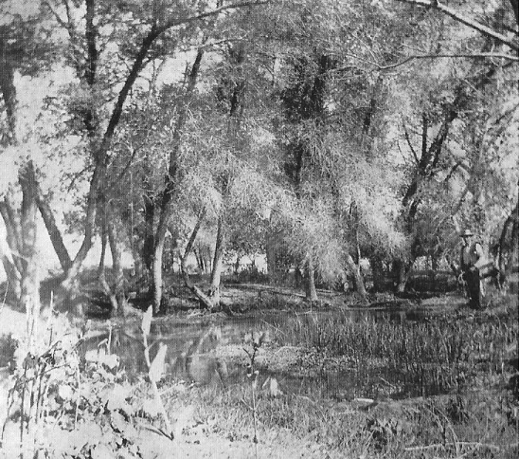
A pond formed by one of the Manse Springs, circa 1895. Man standing is unidentified. The picture may have been taken looking south. Photo courtesy of Joyce Yount Dangermond.

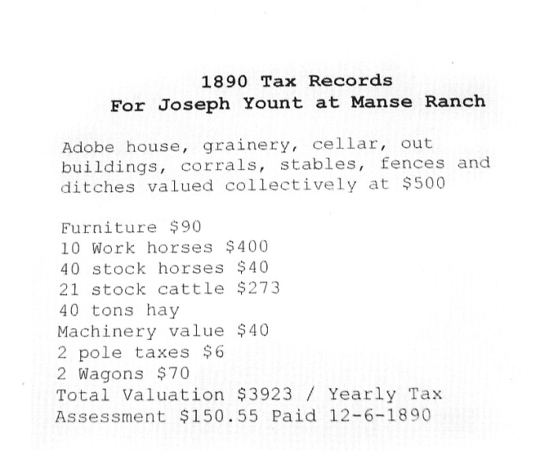
Itemized Manse Ranch tax assessment, 1890. Courtesy of Pahrump Valley Museum

MANSE RANCH TAX RECORDS

Tax records provide insight into life at the Manse Ranch. In 1886 Joseph Yount's name appears in the December 4 Belmont Courier listing of those in arrears on their county property taxes. Yount, it seems, owed $151 In back taxes including $130 .45 In property taxes plus $4 for a poll tax, a $1 dog tax, and 10 percent delinquency penalty amounting to $13.55 and $2 for. advertising. 'Taxable property included 320 acres with improvements, including house, stable, and corral, valued at $2,000; seven horses, at $280; thirteen mustangs, worth $169; two milk cows, valued at $50; thirty-eight hogs, at $152; two wagons, at $80; machinery, at $150; and 30 tons of grain, with a value of $900.
Five years later the Yount family's net worth apparently had in-creased, but once again Joseph was behind in his tax payment. That year he was listed as having 1,600 acres and improvements, including an adobe house, a granary, cellars and outbuildings, a corral, fences, and ditches. There were ten workhorses, thirty-five stock horses, fifteen stock cattle, wagons, machinery, and 80 tons of hay. For tax purposes, his property was valued at $4,274 and he owed $143.08 (Belmont Courier, December 19, 1891).

BUCKBOARD VISITOR: BROOKS'S ACCOUNT

In March 1886 a resident of Pomona, California, named Thomas W. Brooks traveled by way of a "desert wagon drawn by a span of fat mules" from his home in the Los Angeles basin to the ranch owned by W. M. Stockton, located at the south end of the Oasis Valley near the future site of Beatty, Nevada. On the trip, Stockton was Brooks's traveling companion and, presumably, guide." Brooks published an account of his trip in the Pomona Times-Courier on April 1 o and April 17, 1886, originally titled "To Death Valley." In 1970 his articles were republished in a lovely small book edited by Anthony L. Lehman titled By Buckboard to Beatty: The California-Nevada Desert in 1886. Brooks stopped at the Manse Ranch on his way to Beatty, and his descriptions of what he saw there are the best surviving account of the Younts and what their nine years of hard work had brought forth."
Brooks and Stockton initially stopped at the Pahrump Ranch on March H, 1MB, one week after having departed Pomona. The ranch was, Brooks wrote, owned by Aaron Winters. Winters and his wife, Rosie, had received $20,00o For the sale of their borax claims located not far from Furnace Creek to William T. Coleman in 1881. They used the money to purchase what became the Pahrump Ranch and the trading post there from Charles Bennett. Brooks described the property as "a large farm place, containing a whole section of land. There is a large quantity of water flowing from springs upon his ranch. There is a fine orchard, and raising the general products of the soil is combined with raising hogs, horses and cattle" (Lehman, 1970:8-9). The travelers apparently stopped for only a few hours at the Pahrump Ranch. "Six miles further, and a total of twenty-four miles for the day, and we arrived at the 'oasis,' a fertile, happy home, the ranch of Mr. Yount"

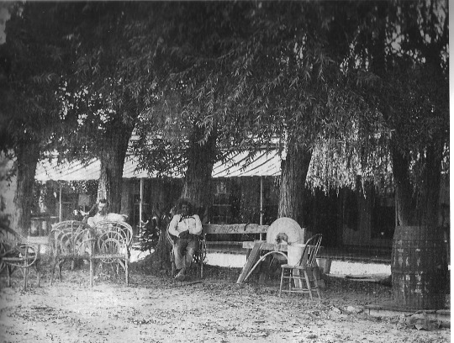
Two unidentified men seated in front of the main house at the Manse Ranch, circa 1900. Photo courtesy of Joyce Yount Dangermond.

Brooks was lavish in his praise for the Younts' moral virtues. "'Tis here," he wrote, "that many youths, grumbling maids, fathers and mothers, could come and read a valuable and interesting lesson of natural life" (p. g). He especially praised Margaret Yount, described as "noble and brave" (p. o). "Too much praise cannot be given the precious mother, Mrs. Yount, who has reared five sons and five daughters here. And though the church, the schoolhouse and the tick of the telegraph was far away from their oasis home, intelligence and cultivation are there, after nature's own design, and void of the superfluous vanity with which the masses are burdened. They are wise and happy". "A dearer home," he wrote, "or more luxuriously supplied, or more convenient, or happier, cannot be found"
Brooks described, with some inaccuracies, how the family ended up in Pahrump Valley. He mentioned the trip from Oregon to Nevada and told how the Indians killed the Younts' horses. He described the acquisition of the ranch from "a Mr. Jordan," writing that Joseph Yount bought the squatter's rights for $800 in cash and seventy-five head of American cattle. The right included 16o acres of land and the water of a "grand old spring." "The soil," he wrote, "is superb and, having great abundance of warm water and climate just right, all of the requirements to build a luxurious home were combined". Brooks noted that "the farm" consisted of 320 acres purchased from the state of Nevada.
"True it is," Brooks wrote, "that it should be called the 'Oasis.' A fertile spot, ornamented with fragrant flowers, evergreens, and every useful product for the comfort and use of man and beast, orchards and vineyards, preserves, raisins and wine, turkeys, ducks, chickens, and geese to the number 400, fish swarming ponds, large and long, which have one hundred inches of warm water continually flowing through them" (p. 12). The farm, he attested, "is capable of producing a better quality of every variety of product that is produced in Los Angeles County than any [other] farm in Nevada" .
Brooks wrote at one point that Margaret Yount, perhaps in exasperation with the family's circumstances, asked her husband, not long after their arrival in Pahrump, "Where are we? Where are our neighbors; the church; the schoolhouse and the postoffice?" His answer: "We are in Palorump [Pahrump] Valley, Nye County, Nevada and Mr. Bennett, six miles distance, is our only neighbor, except that we consider the hundreds of roving Paiutes neighbors; and to the church, the schoolhouse and postoffice, I hardly know which is nearest, the settlement on Kern River, the Mormon Church in St. George, Utah, or San Bernardino, but it is 25o miles to the nearest postoffice"
Brooks continued, "The situation was despairing to Mrs. Yount . . . especially considering the little girls and boys who were soon to be men and women. But the conditions were accepted, and with untiring energy, and the blessing of good health, and judicious management, they went to work, and have made a grand success"

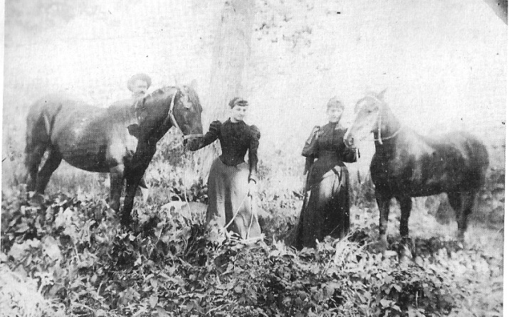
Nellie Yount and Della White with their horses, circa 1895. Sam Yount is at far left. Photo courtesy of Dr. James Ferguson.

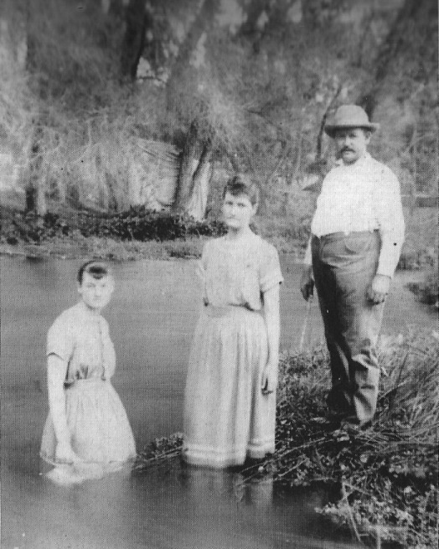
Nellie Yount, Della White, and Sam Yount cool off in one of the ranch's ponds, circa 1895. Photo courtesy of Dr. James Ferguson.

STAGE CONNECTIONS WITH THE MANSE

The newborn communities in the area, as well as the newly constructed railroads, fed to an increase of interest in and traffic to and from the Manse Ranch. By 1905 the ranch was being served by the Star Route Stage Company. The company's stages ran between Beatty, Johnnie, and Manse. The stage left Beatty on Tuesday and Saturday and the Manse on Monday and Friday. The fare was 522 from Beatty, according to an item from the Beatty Bullfrog Miner (June 17, 1905).
The February 9, 1907, issue of the Miner carried word that another stage company was in operation—the Manse, Pahrump, Johnnie & Amargosa Stage Line. The stage left Amargosa on Monday, Wednesday, and Friday after arrival of the mail on the train from Las Vegas, which was due at 3:50, but would leave no later than 6 p.m. It would arrive at the Manse Ranch ten hours later carrying U.S. mail, passengers, and express. The company's ad read, "Good New Rigs, good stock and careful drivers" (Beatty Bullfrog Miner, February 9, 1907).

LARGE-SCALE DEVELOPMENT IN PAHRUMP

The Yount family's success in making the desert bloom fired the dreams of others. With the founding of Las Vegas and Rhyolite-Beatty and the coming of three railroads at the beginning of the twentieth century, it appeared that what had been accomplished at the Manse Ranch, and, to a lesser extent, at the Pahrump Ranch, could be done for the Pahrump Valley as a whole. For example, an item in the Beatty Bullfrog Miner on November 25, 1905, referencing the Los Angeles Times, told of a colony of California farmers intent on settling in the Pahrump Valley. "Some years ago," it said hopefully, "a colony of tenderfeet from the East made a failure of the colony scheme, but it was not the fault of the country. White's ranch at Manse shows what can be done there."
Charles Bennett and his wife show up in the Beatty Bullfrog Miner on September 23, 1905, in connection with an early colony. The newspaper correctly states that the Bennett family settled at the Pahrump Spring in 1875, but it goes on to say Bennett later sold the ranch to a company proposing to establish a colony there, turning it into, as the newspaper put it, a Garden of Eden. The buyer, apparently the Calivada Colonization Company, still owned the property as of 1905, and it was managed by a man named C. C. Orr. The colony is said to have succeeded to some extent, but failed, as the newspaper put it, because of internal strife.
Potential for large development in Pahrump Valley did not go unnoticed by powerful capitalists. Senator William A. Clark's newly formed railroad linking Salt Lake City and Los Angeles, his Las Vegas and Tonopah line, and Francis Marion "Borax" Smith's Tonopah and Tidewater Railroad made people stand up and pay attention.
In April 1906, E. H. Harriman, E. L. Lomax, J. C. Stubbs, and E. 0. McCormick enjoined William M. Martin to make a trip to the west side of the Spring Mountains, where they planned to "open up 600,000 acres of rich agricultural and grazing lands" (Beatty Bullfrog Miner, April 7, 1906). In his report Martin stated,

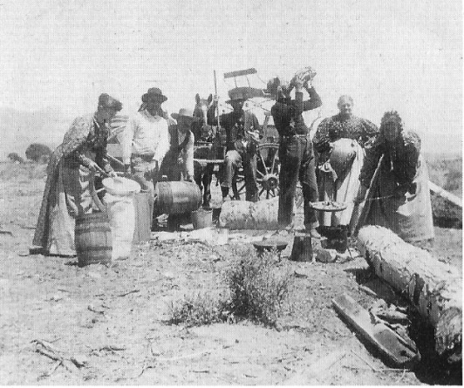
Cookout at the Manse Ranch, 1889. Margaret Yount is second from right. Photo courtesy of Dr. James Ferguson.

The lands are south of the Amargosa desert and west of the Spring range of mountains, lying partly in Nevada and partly in California, in the Pahrump Valley. It is one of the most fertile spots in the Western States. The valley is partially surrounded by a range of mountains varying from 6,000 to 13,000 feet above sea level, the valley itself being about 3,000 feet. There is a heavy growth of timber, yellow pine, nut pine and tamarack, affording a continual supply of lumber and fuel.
Martin wrote, "I have roughly calculated the area of arable land in this valley to be at least.3oo,00o acres, and as much more for pasture" (Beatty Bullfrog Miner, April 7,, 1906).
The railroads, of course, were interested in getting the "country settled up" because settlers meant increased business, bringing in supplies and shipping out what was produced.
In 1910 the Tonopah & Tidewater and Las Vegas & Tonopah railroads were interested, as the Tonopah Daily Bonanza (November 17, 1910) put it, in "a monster reclamation scheme involving the development of the great Pahrump Valley and Ash Meadows bottoms." The idea was to develop the agricultural potential of the two areas. Pahrump, the article said, compared favorably with the Imperial Valley east of San Diego, California, for growing cotton. Pahrump peaches were like those from New Jersey, and its apples, big and perfect, were without worms. "In fact," the article reported, "it is remarkable that everything grows there to perfection." But the scheme, like so many others, seems never to have gotten off the ground.

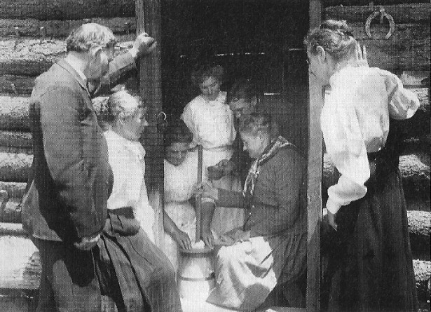
Annie Yount Gardner and Margaret Yount churning butter, circa 1900. Photo courtesy of Dr. James Ferguson.

RELATIONS WITH NATIVE AMERICANS

During the first years at the Manse, relations with the local Native Americans seem to have been relatively peaceful, but there must have been occasional rough spots as the Euro-American and Native American cultures clashed, sharing the same environment. Occasional pilfering by Paiutes of livestock and crops was one source of conflict. The Las Vegas Age (May 7, 191o) published a retrospective on an encounter thirty years earlier that, as far as the Younts must have been concerned, settled an old score. The article describes the isolation the Yount family experienced at the Manse Ranch in 1877. "The railroad was then hundreds of miles away. San Bernardino was the nearest trading point, and in the whole• expanse of desert, hundreds of miles in extent, but few settlers were to be found aside from the miners and prospectors scattered through the hills."
The article noted that Indians on occasion made trouble in decades past by killing and stealing stock from the settlers. Finally, in about 188o, the settlers and miners had had enough. A meeting was held at Ivanpah, and the Indians were notified that "the guilty ones must be brought to justice." Two members of the tribe were taken hostage, and word was sent to their relatives "that the culprits must be caught and punished or the lives of the hostages would be sacrificed." A band of Native American trackers set out on the trail of the criminals, who were "known to be Panquitch and Horseshootem." The trackers followed the fugitives for many miles across the desert and mountains. Finally, at the Wilson Ranch west of Las Vegas, Panquitch was confronted. The Las Vegas Age described the action as follows: "One Indian caught and pinioned the criminal's arms and the other quickly picked up an ax and split his skull open." The Wilsons were called as witnesses, and proof of Panquitch's death was sent back to Ivanpah.
The search for Horseshootem continued. After many days of pursuit, he was overtaken near Tybo in northern Nye County, "nearly Soo miles," the article said, from "the scene of his crimes." Horseshootem was shot in the back, and proof of his death was sent to Ivanpah. Thereupon, the hostages were released. As was noted earlier, Horseshootem had been involved in the killing of the Younts' draft horses in 1876, which had led to the family's settling in Pahrump Valley.
Following the deaths of Panquitch and Horseshootem, "Indian troubles" are said to have ceased for good. Native Americans and their families often found employment at the Manse and other ranches in the area. It was common for families to establish intermittently occupied residences on the margins of the ranches or near small desert communities in the area.

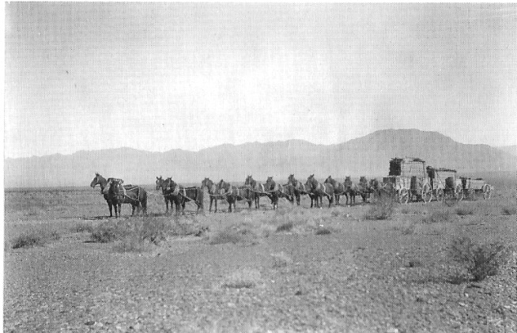
Three wagons of freight pulled by a fourteen-horse team. Photo courtesy of Dr. James Ferguson.

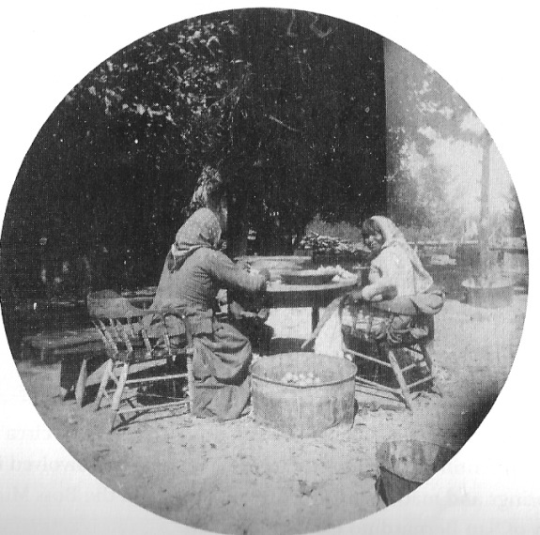
Native American women preparing food, circa 1900. Photo courtesy of Dr., James Ferguson

The Native Americans, however, did not prosper from the white man's presence. In 1905, Harsha White was quoted as saying the Paiute Indian population in the area had decreased by 6o percent since 1890. He attributed their undoing to "the white man's whiskey and biscuits and love" (Beatty Bullfrog Miner, September 23, 1905).
Chief Tecopa died of old age in 1904. It was his wish to be buried like a white man. To accommodate his request, he was dressed in his bandmaster's suit trimmed with red braid and a plug hat and laid to rest in a box in the "gravely ground." The suit, it was said, had been a gift from George Montgomery, and the plug hat had come from Ivanpah friends who loved the old chief who had once saved their lives from a raid of hostile Indians.
In September of 1905 the Paiutes held a pow-wow at a spring south of Manse, possibly at what became John Yount's ranch, later Roland Wiley's. About 100 men, women, and children gathered to feast and give sacrifice to appease the wrath of their gods who had called so many of their members to death. There was feasting and dancing and recollection of the glorious days when the Paiutes put the Shoshones to flight. Then the ceremonialists met at the grave of Chief Tecopa and burned clothing and blankets and killed several ponies to "square themselves with the Great Spirit for the coming four years," as the Beatty Bullfrog Miner put it (September 23, 1905).
Living in close proximity with the local Native Americans for so many years, the Younts became privy to much of the Indians' knowledge of the vast territory over which they roamed and of its history. Harsha and Maude White's son-in-law Jim Fisk, an adventurous Mojave Desert man in his own right, reported that after years of close contact and employment at the Manse, the Native American women told of their people's capture and torture of Charles C. Breyfogle. Breyfogle, of course, was the New Yorker who in I865, became lost in the Amargosa region and, while attempting to get back to what he believed was the Lost Gunsight Mine, was captured by Southern Paiutes. Fisk said, "The kids used him as a horse and made him go on all fours, prodded him in the stomach with sticks to make him 'buck.'" At one point, an Indian boy hit him on the head with a hatchet, which, it was said, caused Breyfogle's memory to become impaired (Fisk documents, Fisk file, San Bernardino County Museum).

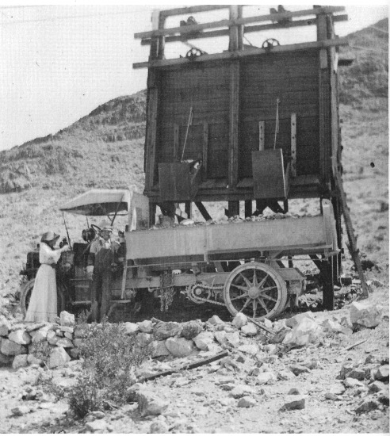
Ore bin and truck, Boss Mine, near Goodsprings, Nevada, circa 1915. Man and woman unidentified. The Yount family members were involved in mining at Goodsprings and made a great deal of money from the Boss Mine. Photo courtesy of San Bernardino County Museum.

YOUNT MINING

From their first days at the Manse Ranch it was mining in the Death Valley region that made the Yount family's survival possible. The miners and the ranchers existed in a symbiotic relationship; each needed the other to survive on the desert. The ranchers provided the miners with food. Through their purchases, miners provided income to the ranchers.
Yount family members were also actively involved in mining from their earliest days on the Manse Ranch. As the Yount boys grew older they became significant players in mine operations in such camps as Montgomery (later known as Johnnie) and Good-springs. Chief Tecopa's son John found the Johnnie ledge, "best in the district," it was said. The Yount boys found another rich outcrop nearby (Lingenfelter, 1986:190). Chief Tecopa is said to have shown Joseph Yount the site of the Boss and Columbia mines at Goodsprings. Both had been previously worked, the former owners thinking the dark, copper-colored ore was silver or another metal. Joseph Yount and Harsha White formed the Yellow Pine Mining Company in the Goodsprings area.
The Belmont Courier of May 2, 1891, carried part of a letter from Harsha White, who by that time was Nye County's deputy sheriff and assessor, to Nye County Clerk F. R. Brotherton. Speaking of Montgomery in his letter, White wrote, "The Yount boys are at work on the claims we have located in southwestern Nye County. They are only down about twelve feet, and they are getting very fine ore; the gold is fine but rich." The Montgomery Mining District, later renamed Johnnie, was located in 1890 or 1891, according to Helen Carlson (1974). It was discovered by George Montgomery and five men from San Andreas, California, who it is said were looking for the lost Breyfogle Mine. A campsite and a post office were established there from 1891 to 1894. The Chispa Mine was the principal producer of the district.
In the early summer of 1891, the Candelaria Chloride Belt (June 6, 1891) reported that the Yount brothers owned the North Belle Mine, located north of the Chispa in Montgomery. "It has a shaft fifty feet deep and a crosscut twenty feet deep to the south cutting the ledge, which is six feet wide. It prospects well in gold and sulpherets, which contain silver and lead."
In their report to Nye County Recorder and Auditor W. Brougher, George E. Crowell and Henry Metz (dated April 22, 1891; Belmont Courier, May g, 1891) described Montgomery Camp as a very "quiet place," with many people having been there and left. The report states, "There is another camp about three miles to the northeast of here. It is called the 'Yount Camp.' There are about io men over there. We staid [sic] there one night. They showed us their claims, they have some good locations. They have sunk a shaft about 25 feet on one claim; it looks very well. In quartz, where there is no gold to be seen, they get a big showing in the horn spoon." A mining man was in town from the Troy District, located on the east side of the Grant Range in northeastern Nye County, the newspaper noted, trying to book claims, including the Yount property.

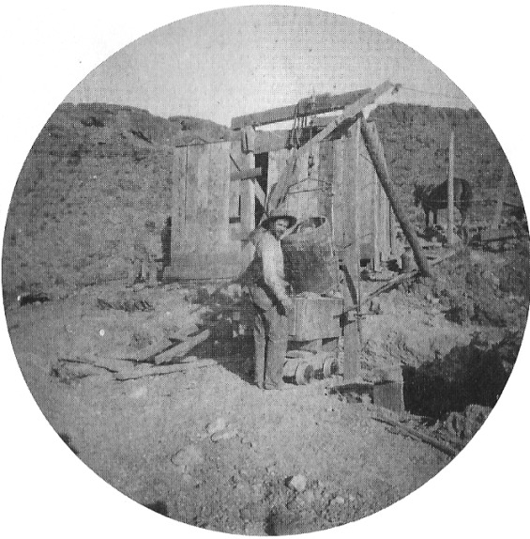
Unidentified man working at a mine in the Pahrump Valley area, circa 1895. Photo courtesy of Dr. James Ferguson.

Harsha White wrote a letter to Nye County Clerk F. R. Brother-ton dated September 6, 1891 and printed in the Belmont Courier on September 26, 1891. Referring to a trip to Montgomery, he stated,
"I was up at the mines last week accompanied by Mrs. White and daughter, Miss Yount, Mr. and Mrs. Nay and Miss Mete from the needles who are visiting here. Being the advent of the first ladies in camp, extensive preparations had been made together with a suitable platform for dancing. Music was furnished by professors McFee, Montgomery and Helm, and all enjoyed themselves immensely until too tired to dance, too well served to eat and too sleepy to talk. All retired at a very late hour to rest for exercise the next day, which consisted of guests inspecting the mines on which work had been done.
There was a tour of the Chispa with its three shafts, which went down 50, 70, and 100 feet, respectively. Samples at the mine across the bottom averaged $70 a ton. Ore was 12 feet wide, with the limit not reached.
The Younts were also involved in mines and other economic activities in the Goodsprings area. Joseph Yount is said to have located the spring in the town of Goodsprings in 1882. Sam Yount spent decades in the Goodsprings area and was apparently quite successful. In 1914 he and a partner, George A. Fayle, purchased the Bullion Mine, located 6 miles south of Goodsprings, for $6,000. After taking out $50,000 worth of ore, they sold it in 1916 for $50,000. Both Yount and Fayle were described as "pioneer merchants and mine operators in Goodsprings" (Reno Evening Gazette, June 2 9 , 1916). In 1914 the Boss Mining Company, owned by Sam Yount, Harsha White, James Fisk (Della White Fisk's husband), and a partner from Goodsprings, sold it for $5o,000 "in cold cash" and two payments of $50,000 each at six-month intervals for the following year. Not long after the company's sale, platinum and gold ore worth $2.50 per pound was found in the mine (Las Vegas Age, December 5, 1914).
Following completion of the Tonopah & Tidewater and Las Vegas & Tonopah railroads in 1906 and 1907, respectively, markets for the produce from the Manse Ranch declined. Diminished sales of mining stocks and the Panic of 1907 only added to the problem.

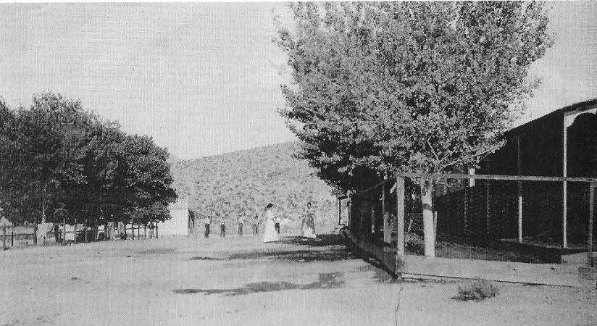
Spring Street, Goodsprings, Nevada, circa 1900. Photo courtesy of Dr. James Ferguson.

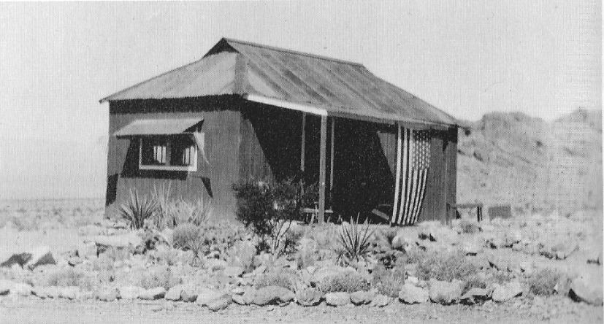
Residence of Della White Fisk and her husband, Jim Fisk, near the Boss Mine, Goodsprings, Nevada, circa 1910. Photo courtesy of San Bernardino County Museum.

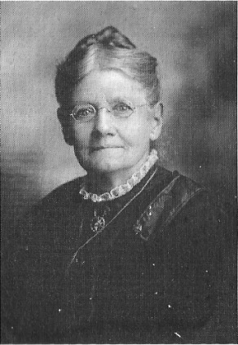
Margaret Parent Yount, wile of Joseph Yount, circa 1910. Photo courtesy of Joyce Yount Dangermond.

MAN OF THE WEST RETIRES

In 1898 Joseph Yount, the grand old man of the West, then eighty years old and with fading vision, left the Manse Ranch on the Nevada frontier and took up permanent residence in San Bernardino, California. On January 3, 1907, at the age of eighty-eight and nearly blind, he died. Of his passing, Mrs. Helen J. Stewart, pioneer woman herself and grand dame of Las Vegas society, is reported to have said Joseph Yount was a splendid citizen respected by all who knew him, and one who did much to promote the development of the region. His obituary in the Beatty Bullfrog Miner (January 19, 1907) contained the following passage: "After a life spent on the frontier pushing civilization into the remote corners of the land and aiding in building up many communities in the west, the aged man departed on the soil he had helped wrest from Mexico in the early days. The end came peacefully, and with one exception, all his children were at the bedside when death came and gently led the old man across the Great Divide." His widow, Margaret Yount, inherited Joseph's interest in the ranch.
Following Joseph Yount's death, Margaret filed an affidavit claiming a widow's pension. She filed her claim March 8, 1907. She was requested to provide proof of Yount's military service and proof that they had been married. She provided official documents showing that Joseph Yount joined the U.S. Army on June 16, 1846, enlisting for twelve months, and that he mustered out June 21, 1847. Joseph Yount had applied for a military pension on June 12, 1888, declaring his service as "from Santa Fe to El Paso, from there to Matamoras, Mexico, in the battle of Brazeto near El Paso, battle of Sacramento near Chihuahua." He listed his height as 5' 7 1/2" inches, dark complexion, black eyes, brown hair. He cited his occupation as farmer. He was awarded a pension of S12 a month apparently on March 3, 1903. Margaret produced a marriage license verifying her mal t iage to Joseph on May 29, 1853. in the absence of documents at hand it is assumed that Margaret was awarded her widow's pension.
In 1910 a gathering honoring Margaret Yount's seventy-sixth birthday was held in San Bernardino at the Yount home at 451 Ninth Street. The following verse by nineteenth-century English author Emily Taylor was read on the occasion:

Has thou sounded the depths of yonder sea?
Has thou counted the sands that under it lie?
Has thou measured the heights of heaven above?
Then hast thou learned of the height and depth of a mother's love.

That event marked the first time in twenty-five years that all the family had gotten together. Present were Margaret's daughters, Mrs. Laura Childers of Woodland, California; Mrs. Maude White and Mrs. Annie (Joanna) Gardner of San Bernardino; Mrs. Fanny Nay of Needles, California; and Mrs. Nellie Meehan, Cherryville, Kansas; and her sons Sam Yount of Goodsprings, Nevada; Leroy Yount of Redlands, California; and John B. Yount of Goodsprings, Nevada; along with their spouses, Harsha White, George Nay, Mrs. Sam Yount, Mrs. Leroy Yount (accompanied by sons John, William, and Lloyd); and granddaughter Della White Fisk and her husband, James (O. J.), of Chino, California. Also present were numerous invited guests including old friends of the family who had crossed the plains with them to Oregon in 1862.

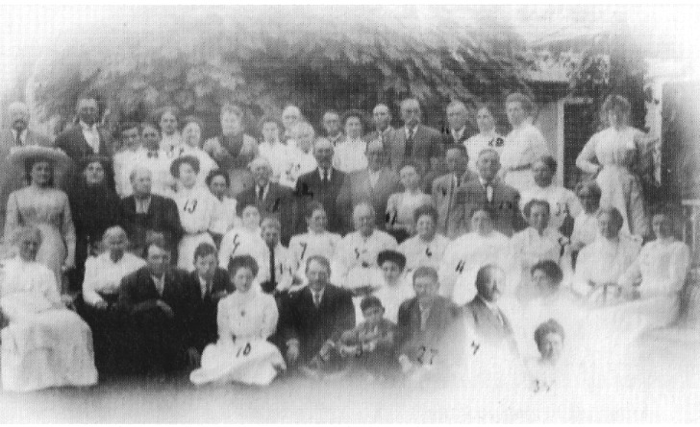
Family photo likely taken in San Bernardino, California, July 1910. Note the added images to the lower right. The woman with the number io is Della White Fisk; Harsha White is sitting on her left. Photo courtesy of Dr. James Ferguson.

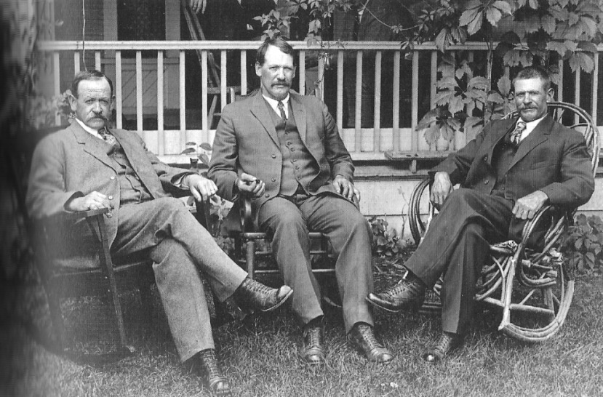
Sam, Leroy, and John Yount, surviving sons of Margaret and Joseph Yount, seated at the family home in San Bernardino, California, 1911. Photo courtesy of Joyce Yount Dangermond.

Margaret Yount died at her home in San Bernardino in 1912 after a long illness, which her obituary said "she bore with Christian resignation." She was treated in her illness by her grandson Dr. F. M. Gardner, son of daughter Joanna Gardner. All of her children but the twins (William and Thomas) were at her bedside when she passed—Laura, Maude, Annie, Sam, Leroy, Fanny, John, and Nellie.
Following Joseph Yount's death in 1907, Harsha White began making plans to sell the family's Nevada holdings. White reported in Las Vegas in 1907 that he arranged for the sale of his entire property, including the Manse Ranch and the sawmill and timber, but a sale did not take place until three years later, in 1910.
A report in the Las Vegas Age on May 7, 1910, states that Harsha White sold the Manse Ranch for $50,000 to a Mr. Hoffman and a Mr. Vetter of Redondo, California. The property consisted of 760 acres, of which 300 were under cultivation, and 400 acres of timberland in the Spring Mountains. The buyers apparently had big plans for the Manse. Their intention was to construct a reservoir 8 acres in size and 12 feet deep. Its purpose was to conserve water to enable the cultivation of the ranch's 760 acres, leaving water to sell to other nearby growers. The article quotes, "The source of the water is a natural artesian spring forcing the water up through the white sand with considerable force, similar to the Vegas springs." O. J. Fisk, Harsha White's son-in-law, said the property sold for $48,000 (notes from an interview with O. J. Fisk dated 4/23/57 in the Fisk file, San Bernardino County Museum).
An unofficial document found in John Yount's home after his death states the property was sold for $45,000. It reports that the property consisted of 750 acres, of which 300 were under orchard, grains, and alfalfa. It also included 400 acres of timberland in the Spring Mountains. The John Yount account confirmed that Hoffman and Vetter were the buyers but noted that, as Germans, they were interned during World War I. They later sold the Manse Ranch for $90,000 to a Frenchman named Cazarang, who was interested only in the 8-acre vineyard. He was later killed, the document says, by a hired hand because of Cazarang's greed and intemperance. The guardians of the estate hired a young Italian named Sam Cataline as caretaker. Cataline was found dead, supposedly of suicide, but the circumstances were said to be mysterious (John Yount document on file, San Bernardino County Museum),

WHAT HAPPENED TO THE YOUNT FAMILY MEMBERS

Laura Childers, Joseph and Margaret's oldest child, was born June 1, 1854. All that is known about her is that she was in attendance at her mother's birthday party in 1910 and at that time lived in Woodland, California.
Maude B. White, the Younts' second oldest, was born June 8, 1856, and died August 10, 1930. She buried a baby in the family plot in Pahrump and a son who was but a toddler in Oregon. The following item appeared in an article on pioneer women in the Beatty Bullfrog Miner on November 11, 1905: "Mrs. Maude White, wife of Harsha White, and daughter of Mr. and Mrs. Yount, must also be classed with the pioneers, for she came to the Manse Ranch with her parents and has resided there ever since. The White home has long been known as a hospitable retreat for prospectors and other travelers, and Mrs. White has played an important part in the upbuilding of Southern Nevada."
Joanna (Annie) Yount, third child of Margaret and Joseph, was born June 14, 1858, in Old Orchard, Nebraska. She was eighty-eight at the time of her death in Yorba Linda Hospital in the San Bernardino, California area (Joanna Yount's undated obituary from an unknown newspaper in the O. J. Fisk file in the San Bernardino County Museum).
Joanna spent most of her girlhood at the Manse Ranch. It was at Manse that she met George Gardner, a miner who was associated with the early development of the famous Gunsight and Noonday mines near Tecopa. The couple were married in August 1877 at the old Starkey Hotel at Third and C Street in San Bernardino, California. The Gardners had three children, the oldest of whom, E M. Gardner, was born in Tecopa and went on to become a physician. The family eventually moved to Attica, New York, where George died in 1886. Joanna spent the next fourteen years at the Attica homestead raising her children, arranging for them to spend several summers on the Manse Ranch while growing up. In the 193os Dr. Garner attempted to purchase the Manse but was unable to put the deal together. After 1900 Joanna returned to California, spending the remainder of her life in San Bernardino.
William and Thomas Yount, Joseph and Margaret's twin sons, were born March 28, 1862. Thomas died October 15, 1881, at age nineteen, and William died September 24, 1896, at age thirty-four. "There were many hardships and heartaches. One of the twins died and the other was killed by Indians," according to a document found at John Yount's home in 1937.17
The sixth child, Edward S. (Sam) Yount, born April 9, 1865, remained in the Death Valley area, residing in Goodsprings for much of his life. He ran a grocery store and hotel there and was deeply involved in mining in the area. Like many merchants on the western frontier, he extended credit to too many miners when they ran short of money and they paid him in shares in mines. Sam moved to Los Angeles in his later years.
Leroy (Lee) Yount, the Younts' seventh child, born August 7, 1867, worked in Death Valley after completing school. While employed at a mine in the area, he and six other miners drank from a pool of contaminated water and developed arsenic poisoning. After becoming sick, Lee went to the California coast near Pismo Beach to regain his health. Following his recovery, he moved to Calico, California, where he was employed as a grocery clerk and later as a butcher. In 1893 he married Mary Ida Furney, whose father was a blacksmith in San Bernardino. Mary and Lee had met earlier while in school. The couple wed in Vanderbilt, where Lee continued his trade as a butcher. One of their three children, a son named John, was born in 1895. In 1897 Lee and Ida moved to a ranch in the Redlands area near where Ida's grandparents the Curtises lived. The ranch had been planted in grapes, but only stumps remained. They grew apricots and later oranges. Lee (lied at the age of seventy-three in 1940.

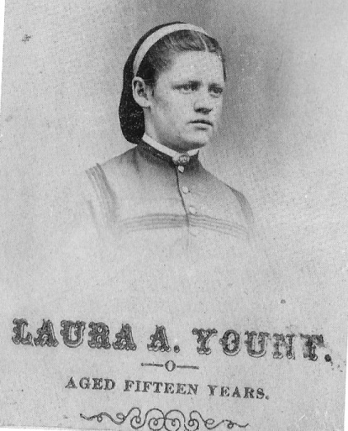
Laura Yount, oldest daughter of Joseph and Margaret, age fifteen. Likely taken in Oregon in 1869, prior to her family moving to Nevada. Photo courtesy of Dr. James Ferguson.

Franco; (Fanny) Yount, the eighth child, born April 27, 1870, married a man named George Nay and lived for sometime in Needles, California.
John B. Yount was born August 8, 1872, and died February 6, 1937. He was the only one of the Yount children who remained in the Pahrump Valley area all his life. He owned Charleston View Ranch, later named the Hidden Hills Ranch by Roland Wiley, who purchased it in the late 193os from the Younts' estate. Wiley constructed his well-known folk-art masterpiece Cathedral Canyon there.
John is the subject of an interesting report in the Las Vegas Age (March 13, 1920). It seems that when John B. Yount was a young man he proved to be a good swimmer. He once went to Los Angeles and competed in several swimming contests. He did not attract much attention at first, but as the contests proceeded people realized that he had beaten the best young man on the coast. He enjoyed a quick, though brief, rise to notoriety. John, it seems, was never much of a talker. He was asked a number of times where he learned to swim. The answer he always gave was, "On the desert." John had learned to swim in the waterhole at the Manse Ranch.
The youngest of Joseph and Margaret's children, Nellie Yount, was born April 8, 1876, only months prior to the family's departure for Nevada. She married a man named Meehan. Nellie and her sister Fanny later moved to Los Angeles. Fanny had a driver's license until she was ninety years old, and the two sisters thought nothing of hopping into the car and speeding into the desert at a rate of speed said to have about matched their ages.
Edward White, the first child of Harsha and Maude, was born July 23, 1873, and died May 3, 1876. He would have been nearly three years old. He died shortly before the Whites' departure from Oregon. Family members today say his unfortunate passing had nothing to do with the Younts and Whites leaving Oregon.
Della May White, the second child of Maude and Harsha White, was born July 4, 1875, in Oregon, most likely in Summerville. She died at the age of ninety-four in San Bernardino, California. She was only a year old when her parents and the Younts began the arduous journey by wagon to Pahrump Valley. Her childhood was spent on the Manse Ranch in the Pahrump Valley, but she was educated in schools in the San Bernardino area. Following her marriage to mining engineer O. J. Fisk, the couple resided in the Mojave Desert area before moving permanently to the San Bernardino, California, area (documents from the O. J. Fisk file, San Bernardino County Museum).
Della May told the story of a woman in the Pahrump area who apparently thought that the Johnnie Mine was worthless and used mining stock certificates issued by the owners to paper over cracks between the boards of her shack to keep the wind out. Not long after that a strike was made at the mine, and the woman is said to have had a devil of a time peeling the stock certificates off the walls.

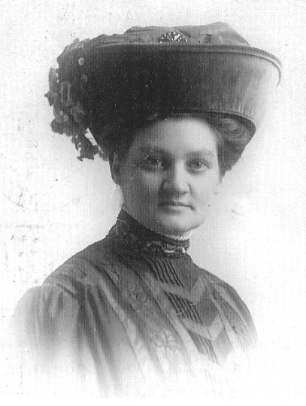
Nellie Yount, circa 1900. Photo courtesy of Dr. James Ferguson.

TABLE 2: Birthdates of the White Family
Harsha White May 3, 1850
Maude B. June 8, 1856
Edward I. .July 23, 1873
Adele (Della) M. ,July 4, 1875

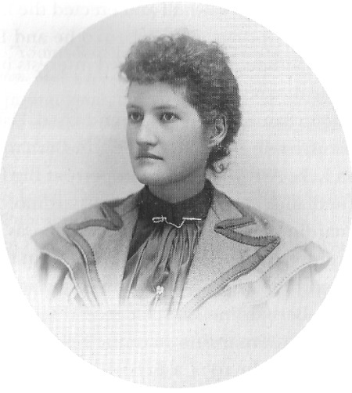
Studio portrait of Della White Fisk taken in San Bernardino, California, circa '1900. Photo courtesy of Dr. James Ferguson.

Della also told a story of Chief Tecopa. The tale may or may not be at odds with the account of George Montgomery giving Tecopa a shirt. Apparently, a local bank gave the chief a nice suit of clothes with a high hat, coat, and pants. He would wear the hat but he did not like wearing the pants. Tecopa rode an old mule with side packs on it. If he would see white folks in the distance, he would get off the mule, pull out his pants, and put them on. As soon as they passed he would take them off again (document from the O. J. Fisk file, San Bernardino County Museum).
Della May married pioneering mining engineer Oliver James (O. J., also known as James or Jim) Fisk in approximately 1894 in Redlands, California. The couple loved the desert, residing in, among other places, Greenwater and Death Valley. While in Green-water, Della May ran a merchandise store. O. J. Fisk was born in Iowa on August 10, 1873, and died at age eighty-seven in 1960. He left Iowa for California with two mules. While in southern Utah, Indians stole his mules and he was forced to cross the southern Nevada desert on
Fisk enjoyed a seventy-three-year career in mining and commercial enterprises in the Mojave Desert arca beginning before the turn of the twentieth century. He constructed and operated some of the largest and most successful mining mills in the gold boom district on the Nevada-California border. At the turn of the century, still in his twenties, he worked as a hoist man at the Gold Bond Mine in Vanderbilt. He constructed an ice plant at Marvel, which supplied ice to the camps of Searchlight, Hearst, Crescent, and Sandy. He was a partner in a transportation firm that hauled freight from the railhead at Ivanpah Dry Lake across the state line and to Pahrump Valley and the boom camps of Beatty, Bullfrog, and Rhyolite.
He was engaged in desert freighting when he met Della May White at the Pahrump Ranch. Freighting led to his forming a partnership with Rose and Palmer. The firm had stores in both Green-water and Silver Lake. Rose, Palmer & Fisk mule teams pioneered what became California Highway 127 from Silver Lake to the Amargosa Valley. Fisk started and owned the stage line that ran from the mining camp of Crackerjack high in the Avawatz Mountains at the south end of Death Valley. He worked with the Yount brothers on the Charleston sawmill and erected the largest of several ore mills at Goodsprings. Around 1910 he and Della moved to San Bernardino although O. J. retained interests in his various enterprises on the desert.
Upon moving to San Bernardino around 1910, Fisk helped engineer the Lake Arrowhead Dam. In the San Bernardino area he had interests in Lake Arrowhead and property at Big Bear. He and Della lived in Redlands and later in San Bernardino.
In San Bernardino Fisk was a civic leader; he was president of the San Bernardino pioneer society and a leader in the formation of the San Bernardino County Museum Association. He was a member of a San Bernardino Elk's lodge and well known for his activities in the San Bernardino Masonic Lodge. O. J. Fisk and Della had no children. In 1974 a $100,000 check was presented to the supervisors of San Bernardino County from Della White Fisks's estate to be used in the construction of a new San Bernardino County museum in memory of Della and her husband.

REFERENCES

Belden, Burr. "Younts Ranch Starts as His Horses Stolen." San Bernardino Sun-Telegram. May 12,1957.
Brown, John Jr., and James Boyd, eds. History of San Bernardino and Riverside Counties, with Selected Biography of Actors and Witnesses of the Period of Growth and Achievement, Vol. III. Chicago: Lewis Publishing Company, 1922.
Camp, Charles L., ed. George C. Yount and His Chronicles of the West. Denver: Old West Publishing Company, 1966.
Carlson, Helen F. Nevada Place Names. Reno: University of Nevada Press, 1974.
Connelly, William Elsey. Doniphan's Expedition and the Conquest of New Mexico and California. Topeka, KS: author, 1907.
Dangermond, Joyce Yount. Documents on family provided by Joyce Yount Dangermond. 2008.
Doherty, John. "History of Settling of Manse Ranch and Territory," Nevada Historical Society Quarterly, Vol. 17, No. 3 (1974):165-168.
Fisk documents, Fisk file, San Bernardino County Museum, San Bernardino, California.
Hardy, Harvey. "The White Petticoat," Old West, Vol. 1, No. 4 (1965): 28-31,62-63.
Lehman, Anthony J., ed. By Buckboard to Beatty: The California-Nevada Desert in 1886. Los Angeles: Dawson's Book Shop, 1970.
Lingenfelter, Richard E. Death Valley and the Amargosa: A Land of Illusion. Berkeley: University of California Press, 1986.
Townley, Carrie Miller. "Helen" Stewart: First Lady of Las Vegas," part 2. Nevada Historical Society Quarterly, Vol. 17, No. 1 (1974): 2-27.
Wheeler, George M. "Preliminary Report Concerning Explorations and Surveys, Principally in Nevada and Arizona." Appendix by Second Lieutenant D. A. Lyle. 1872. Reprint, Freeport, NY: Books for Libraries Press, 1970.
Beatty Bullfrog Miner, June 10, 1905. Beatty Bullfrog Miner, June 17, 1905.
Beatty Bullfrog Miner, September g, 1905. Beatty Bullfrog Miner, September 23, 1905. Beatty Bullfrog Miner, October 7, 1905. Beatty Bullfrog Miner, November it, 1905.
Beatty Bullfrog Miner November 25, 1905. Beatty Bullfrog Miner, April 7, 1906.
Beatty Bullfrog Miner, January 12, 1907. Beatty Bullfrog Miner, January 19, 1907. Beatty Bullfrog Miner, February 9, 1907. Beatty Bullfrog Miner, July 6, 1907.
Belmont Courier, December 4, 1886. Belmont Courier, May 24, 1890.
Belmont Courier, June 21, 189o. Belmont Courier, May 2, 1891. Belmont Courier, May g, 1891. Belmont Courier, September 26, 1891. Belmont Courier, December 19, 1891.
Candelaria Chloride Belt, June 6, 1891.
Las Vegas Age, January 12, 1907. Las Vegas Age, May 7, 1910.
Las Vegas Age, September 30, 1905. Las Vegas Age, October 14, 1905
Las Vegas Age, January 19, 1907. Las Vegas Age, December 5, 1914.
Las Vegas Age, March 13, 1920.
Reno Evening Gazette, November 22, 1910.
Reno Evening Gazette, June 29, 1916.
Tonopah Daily Bonanza, November 17, 1910.
NOTES

1 - Lingenfelter (1986:165, 167) writes that Chief Tecopa had a rancheria at Pahrump Spring and Charles Bennett moved in beside him. Harry Ford was told by Bob Lee, son of Philander Lee, who knew Tecopa and was married to an Indian woman, that Tecopa's rancheria was at Ray-craft Spring, which was much smaller than Pahrump Spring. Bob Lee gave Ford and his classmates at the Pahrump school a tour of the Raycraft Spring in the mid-194os. Ford recalls a large amount of Indian artifacts scattered about. Ford recently confirmed this account with a local Southern Paiute elder. This account holds that Chief Tecopa's son John established a rancheria at Pahrump Spring. In his later life, Chief Tecopa worried that John, his apparent successor, had only "some" of the traits of the wildcat and was "doubtful about allowing John to wear his shoes" (Beatty Bullfrog Miner, September 23, 1905).
2 - Little specific information is available on Yount's military service. An account of the following incident does survive: "Many Mexican sheep were slaughtered for the troops at El Paso. These sheep were small, and often they were thin in flesh and made poor food. Upon one occasion the Quartermaster notified Company F to send up someone to draw its proportion of the carcasses of sheep to be issued that day. Joseph Yount was detailed to go. Yount was a powerful man, with extremely long arms. He was directed to receive the sheep and await a wagon which would follow him to bring back the meat. A short time after he departed someone saw a strange object entering the quarters of the company; the men came to look at what seemed to be a heap of dressed sheep moving into camp. At the commissary they were tumbled down and Yount emerged from the moving pile. He had carried in the full quota of the company-11 sheep. When rallied upon the enormous load he had carried he picked up the lean carcass of a dressed sheep and said, "Look at that!" Then holding it between his eyes and the sun he exclaimed, "Why, I could have read the Lord's Prayer through that sheep!" See William Elsey Connelly, Doniphan's Expedition and the Conquest of New Mexico and California (Topeka, KS: published by the author, 1907), p. 39o.
3 - It seems possible that on one of his trips to or from California, Joseph Yount may have traveled by way of the Spanish Trail, a route that would have taken him across Pahrump Valley, only a few miles from Manse Springs. If this is the case, he would have later had some familiarity with the geography of region
4 - Margaret Yount's obituary (undated, with source unknown), on file at the San Bernardino County Museum, says Margaret left the Manse and took up permanent residence in San Bernardino in 1883. This date is at odds with Colonel Thomas W. Brooks's account of meeting her on the Manse Ranch in 1886, unless, of course, she had returned from California and was visiting the ranch. Though Joseph moved to San Bernardino in 1898, there is no evidence the couple left the ranch at the same time.
5 - An opinion expressed in at least one Yount family document says that Joseph and Margaret left Missouri primarily because of the impending outbreak of the Civil War. Joseph Yount is quoted as saying, "You can't fight for the United States in one war and against it in the next," referring to the fact that he had served in the U.S. Army in the Mexican War. This explanation is not persuasive; Joseph Yount's obituary reports that he had lived in Nebraska and he had participated in the gold rush to Pikes Peak in 1859. It seems more likely that the Joseph and Margaret, frontier people at heart, moved to Oregon in search of new opportunities.
Although family members do not agree, one wonders if, in their move west, the Younts may have had as a role model a man named George Yount. He was not known to be a close relative, or even acquainted with Joseph. George Yount was one of the first Euro-Americans to explore what became the American Southwest. George Yount was born in North Carolina in 1794. When he was ten years old his family moved to Missouri, being among the first American pioneers to cross the Mississippi River. In 1837 he was granted the Caymus Rancho in Napa Valley, California, where he was the first white settler. He resided and flourished economically there for some thirty years, raising cattle, orchard produce, grapes, strawberries, and honey. The town of Yountville in northern California was named after him.
One source says that in the late 187os a traveler returned to Grande Ronde Valley in Oregon from Tombstone, Arizona, where a rich silver strike had recently been made. He "told such wonderful stories of the wealth and opportunities in the new camp, that a number of Valley residents decided to pull up stakes and go to the new boom town. They sold or abandoned their Valley farms, loaded their families and belongings into covered wagons and, driving their livestock before them, set out on a 2,000-mile trek that would take them through Oregon, Idaho, Nevada, California and Arizona." Among those leaving Oregon were the Younts family. This account was apparently told by Sam Yount, sixth child of Joseph and Margaret, to I hive)/ Hardy, an employee of Sam's at Goodsprings, Nevada, beginning in 1908 (Hardy, 1965:28).
6 - Based on interviews with Joseph and Margaret's descendants in the 1950s, Burr Belden suggests another motive (1957). "Oregon was filling up and there was news of unlimited land in Arizona."
7 -Lingenfelter (1986:1(i3) describes Andrew Jackson Laswell as a "bullheaded Kentucky" who was "Death Valley's first homesteader." Laswell and a partner established hay ranches at Bennett's Well and the mouth of Furnace Creek beginning in 1874 before moving to Indian Springs in 1875.
8 - Don Hendricks has suggested that Yount may have become increasingly concerned about getting the cattle across the Colorado River to Arizona. But that leaves unexplained why it took him so long to become concerned.
9 - Another account suggests that it was the twin boys who discovered that the horses had been killed, and that their father was not present at that time. Upon arriving back in camp at Ash Meadows with the news, "their eyes were fairly popping," as they described the tragedy.
10 - This interpretation is also favored by O. J. Fisk, Harsha and Maude White's son-in-law. In an interview dated April 1957 (on file at the San Bernardino County Museum) Fisk states, "Indians later said they figured if they could keep Yount's herd in spot they would have beef as needed, killing cattle as wanted." On September 27, 1905, Joseph Yount and his son Leroy gave depositions in San Bernardino, California, for the U.S. Court of Claims for Indian Depredations, pertaining to his claim asking the federal government for compensation for his livestock killed by Native Americans that first winter in Nevada. Yount, who was then eighty-seven and perhaps blind, or nearly so, stated that in February 1867 he and his family were living in a tent at Ash Meadows, where Indians killed a matched team of hay horses, two cow horses, and one of a matched pair of iron-gray mules. Yount referred to the Paiute killer as Horse Killer, not Horseshutem, and the U.S. Attorney called him Old Horse Shooter. One gets the impression from accounts of other Yount family members that more horses were lost in the episode than Joseph suggests in his deposition, and that the family had moved to the Manse Springs a month or so earlier that, winter.
11 - Another account says Aaron and Rosie Winters occupied the Pahrump Spring. (I pirman:1970, 8).
12 - Doherty (1974) calls them Hordan; most accounts say two brothers.
13 - Clark was also the proprietor of the Manse, Pahrump, Johnnie & Amargosa Stage Line.
14 - William M. Stockton was another exceedingly interesting individual in Nye County history. He was born in Indiana in 1817 and later headed west from Iowa. He was with Jefferson Hunt's wagon train bound from Salt Lake City to San Bernardino when some members of the group who were in a hurry to get to the California gold fields abandoned the main party and took what they thought was a shortcut to the Los Angeles Basin and ended up in Death Valley, gaining fame as the Death Valley 49ers. He later mined with Lewis Manley and Asabel Bennett, who were among the breakaways. By a 855 he had a thriving vineyard nursery in San Gabriel, California. Stockton later moved to Nevada and died there in 1894.
15 - Brooks was born in Georgia in 1825. In 1849 he headed for the California gold fields. After serving in the confederacy, he prospected in Nevada, Colorado, Oregon, and Mexico. He supposedly served as a scout for Custer in the Black Hills where he said he got the moniker "Colonel." After marrying, Brooks settled down in 1882 in the new town of Pomona, California. He died in what seems to have been poverty in 1905 at the age of 79. Brooks and Stockton left Pomona March 1, 1886, and arrived at the Pahrump Ranch on March 8. They traveled by way of Cajon Pass and Stoddards Wells, reaching Daggett on March 4. From Daggett it was on to Otis, then east of the Calico Mountain to Coyote Well, then east of the Granite Mountains to Cave Springs, and on to Saratoga Springs and then Resting Springs, and to Pahrump Valley (Lehman, 1970:1).
16 - Just how this report fits with Charles Bennett's sale of the ranch to Aaron and Rosie Winters is not clear. Perhaps Bennett purchased the ranch back from the Winters. In what may or may not be a related report, two weeks later the same paper noted, reporting on an item from the Carson News, that thirty-five to forty families would arrive in the valley in a month, "where land has already been taken up." William H. Martin was the colonization agent (Beatty Bullfrog Miner, October 7, 1905).
17 - Don Hendricks suggests that Thomas may have died accidently while pulling a gun from a wagon and that William died from "drinking poisoned water."

THE YOUNTS

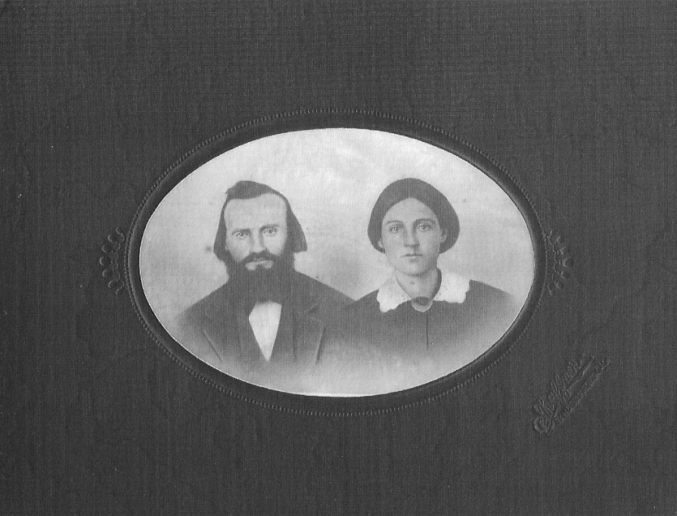
Joseph Yount and Margaret Parent Yount, 1854. Photo courtesy of Dr. James Ferguson.

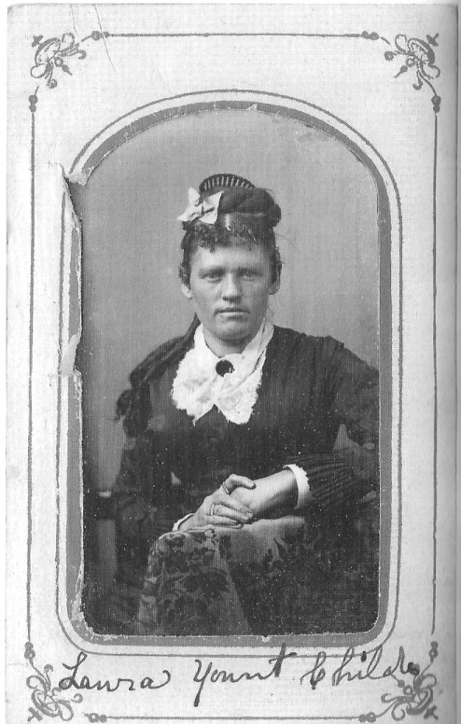
Laura Yount Childers at about age twenty-two. Taken in La Grande, Oregon, 1876.

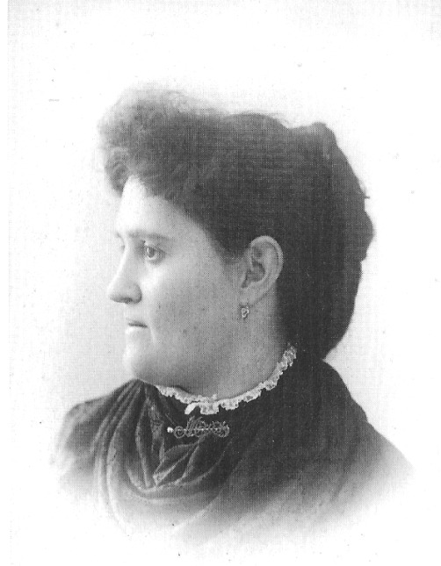
Maude Yount White, second daughter of Joseph and Margaret, 1892. Photo courtesy of Dr. James Ferguson.

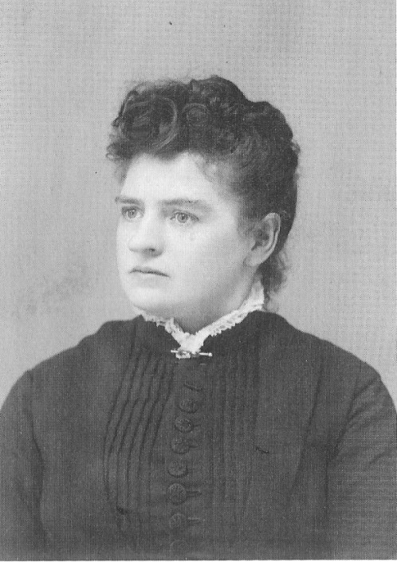
Joanna (Annie) Yount, third daughter of Joseph and Margaret, 1896. Photo courtesy of Dr. James Ferguson.

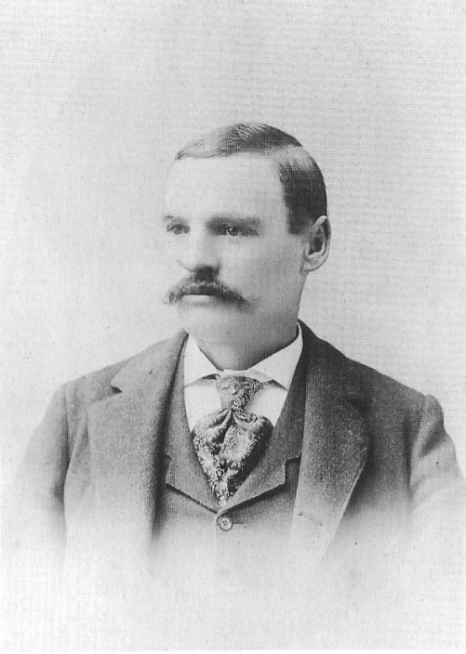
William Yount, 1891. His twin, Thomas, died in 1886, William died in 1896. Photo courtesy of Dr. James Ferguson.

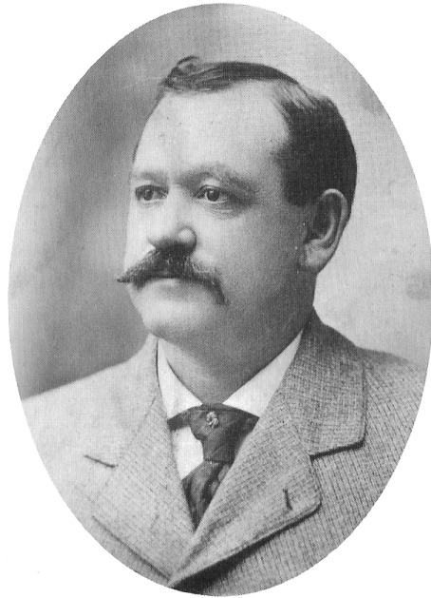
Edward "Sam" Yount, sixth child and third son of Margaret and Joseph Yount, circa 1900. Photo courtesy of Joyce Yount Dangermond.

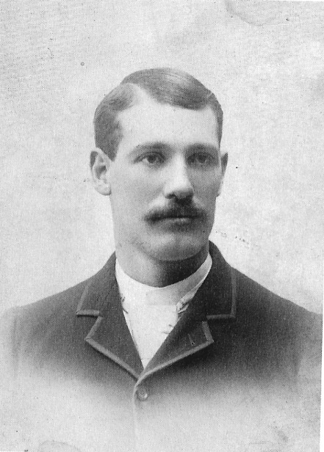
Leroy Yount, circa 1895. Photo courtesy of Joyce Yount Dangermond.

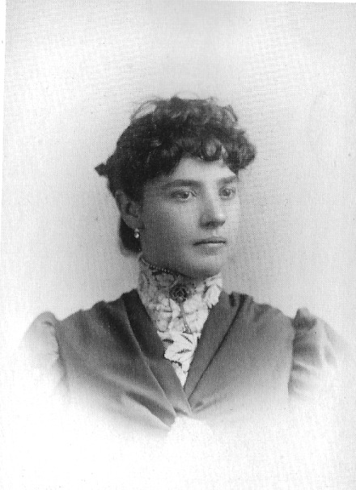
Frances "Fanny" Yount, 1888. Photo taken in San Bernardino, California. Photo courtesy of Dr. James Ferguson.

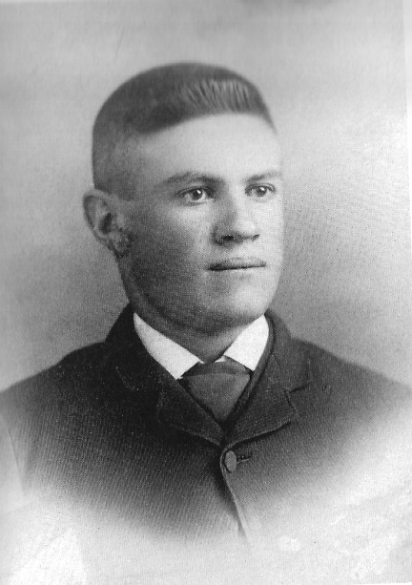
John B. Yount, circa 1895. Photo courtesy of Joyce Yount Dangermond.

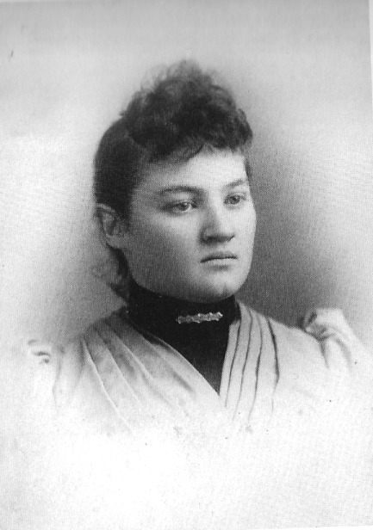
Nellie Yount, the youngest of Joseph and Margaret's children, about sixteen years old, circa 1892. Photo courtesy of dr. James Ferguson.

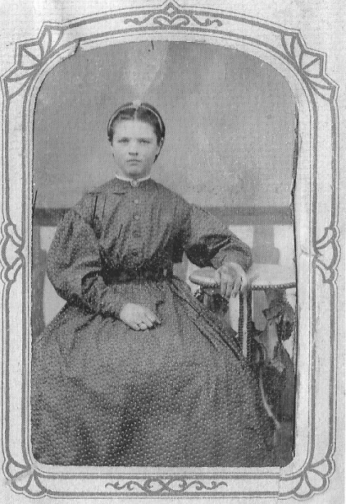
Joanna Yount about age eleven. Taken in La Grande, Oregon, 1869. Photo courtesy of Dr. James Ferguson.

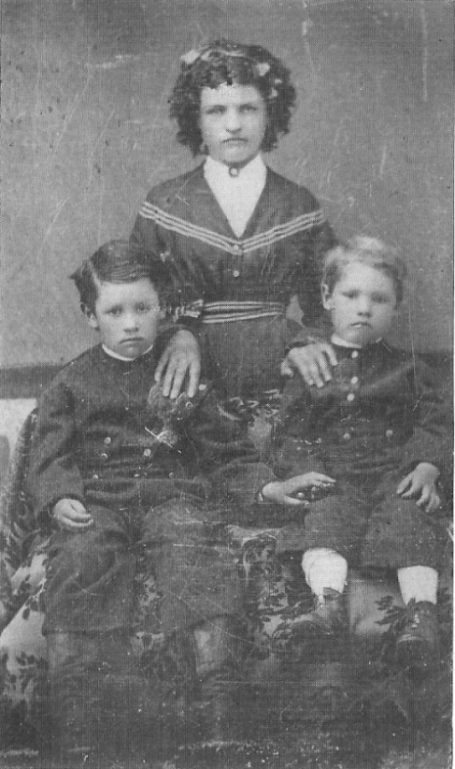
Joanna Yount with brothers Sam (left) and Leroy, circa 1872. Joanna would have been about fourteen years old, Sam about seven, and Leroy about five. Photo courtesy of Dr. James Ferguson.

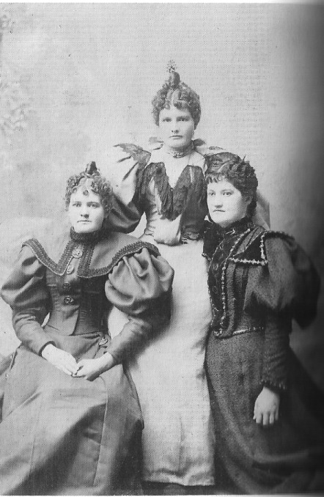
Left to right, Nellie and Fanny Yount with their niece. Della White, circa 1895. Photo courtesy of Dr. James Ferguson.

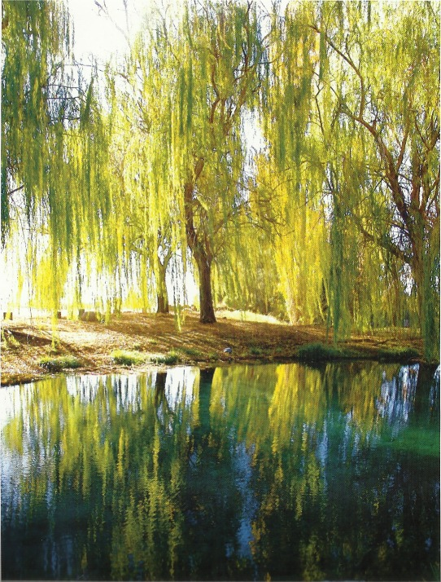
Insert: Manse Ranch December 2008. Photos by Jeanne Sharp Howerton

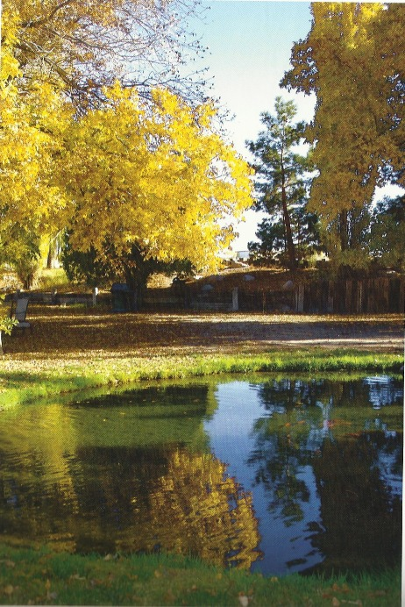

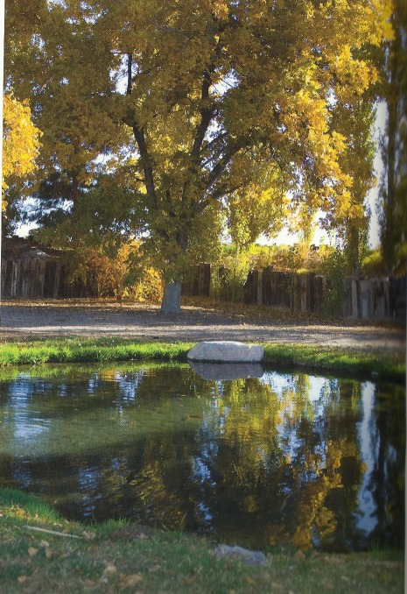

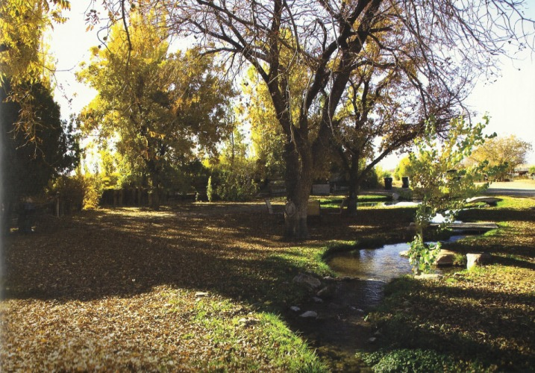

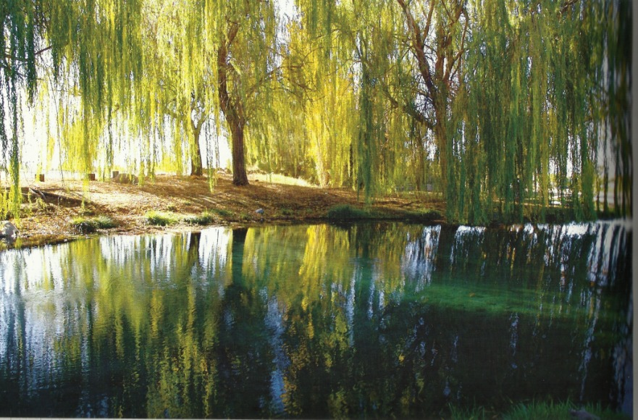

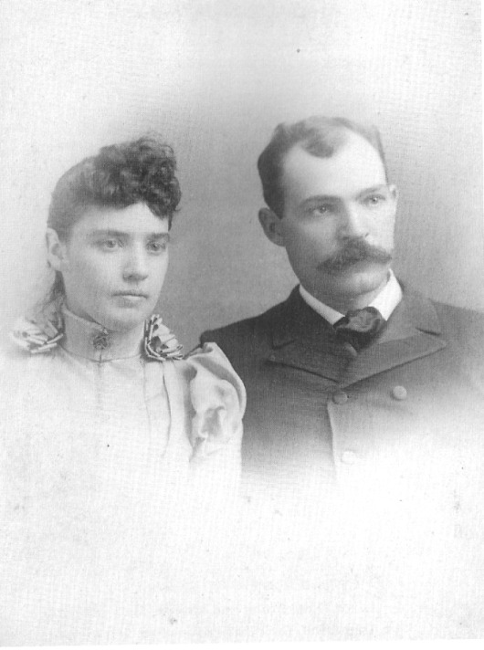
Fanny Yount Nay and her husband, George Nay, circa 1895. Photo courtesy of Joyce Yount Dangermond.

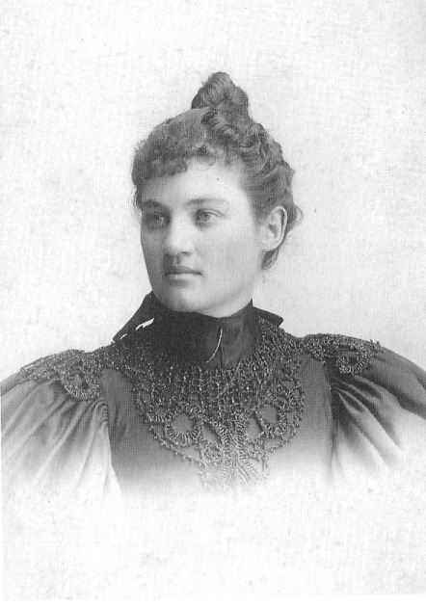
A later portrait of Nellie Yount, circa 1900. Photo courtesy of Dr. James Ferguson.

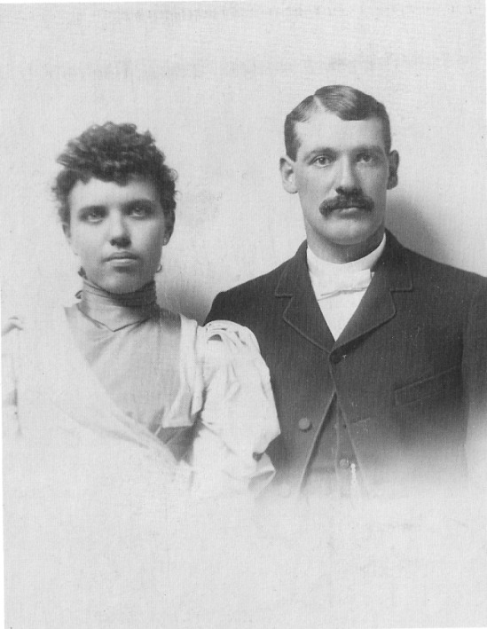
Leroy Yount and his wife, Mary Ida Yount, circa 1895. Mary's father died at a young age and her mother died no long after, so she was raised by her grandparents, the Curtises. the Curtises are said to have come to San Bernardino from Texas in 1870 by way of covered wagon. Leroy and Mary had three boys: John, Lloyd, and Bill. Lloyd died while still a child. Photo courtesy of Joyce Yount Dangermond.

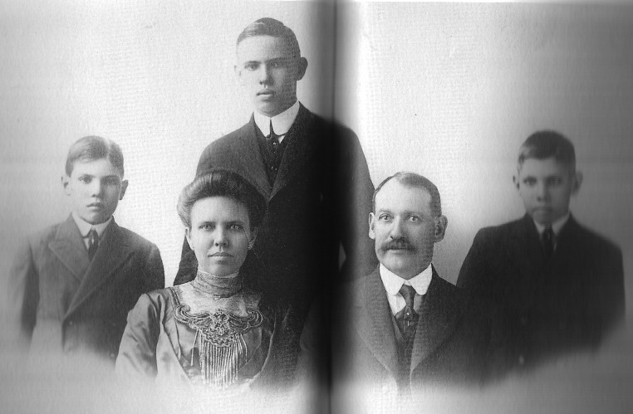
Leroy Oliver Yount and his wife, Mary Ida Ferney Yount, with their three sons - from left to right, Lloyd, John, and Bill. Circa 1905. Photo courtesy of Joyce Yount Dangermond.

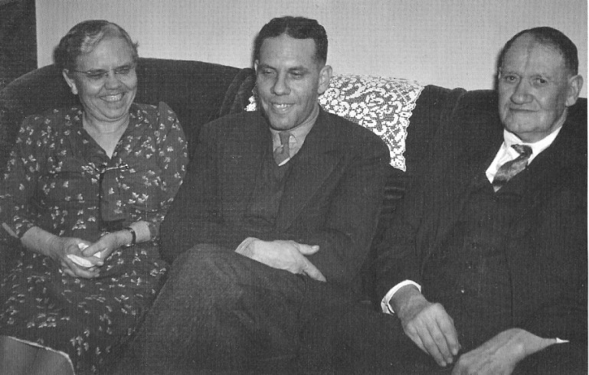
Leroy Yount and his wife, with son Bill, circa 1930. Photo courtesy of Joyce Yount Dangermond.

The Whites

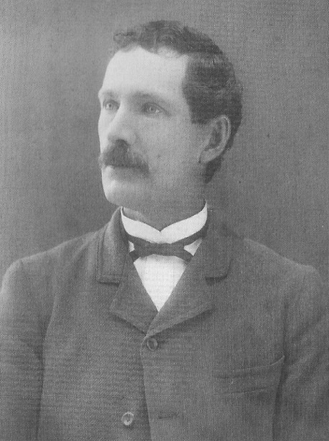
Harsha White, son-in-law of Joseph and Margaret Yount, husband of Maude Yount White, 1892. Photo courtesy of Dr. James Ferguson.

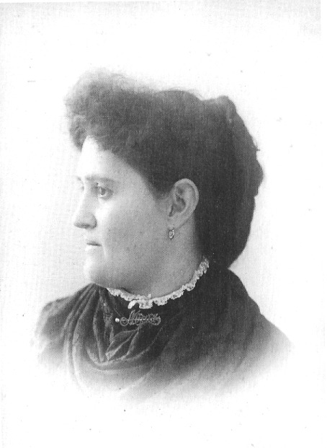
Maude Yount White, second daughter of Joseph and Margaret, 1892. Photo courtesy of Dr. James Ferguson.

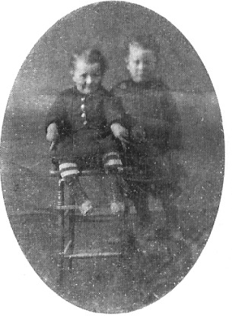
Edward "Eddie" White, firstborn of Maude and Harsha White (left), and John Yount, youngest son of Joseph and Margaret Yount, 1875. Eddie died as a toddler prior to the family's departure for Nevada. Photo courtesy of Dr. James Ferguson.

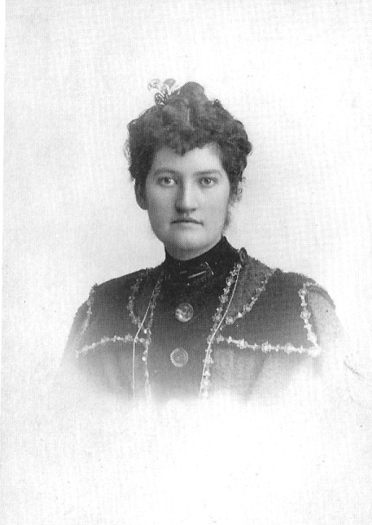
Della White Fisk, 1898, Los Angeles. Photo courtesy of Dr. James Ferguson.

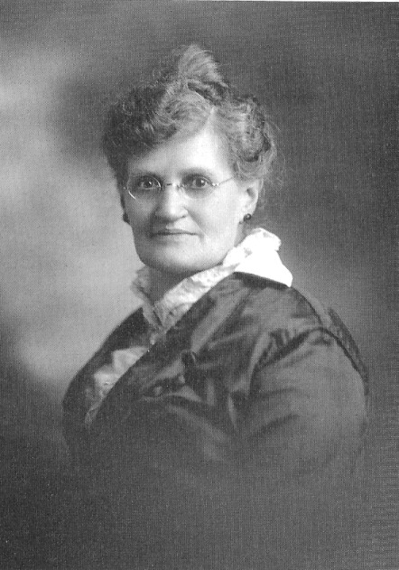
Maude Yount White, circa 1900. Photo courtesy of Joyce Yount Dangermond.

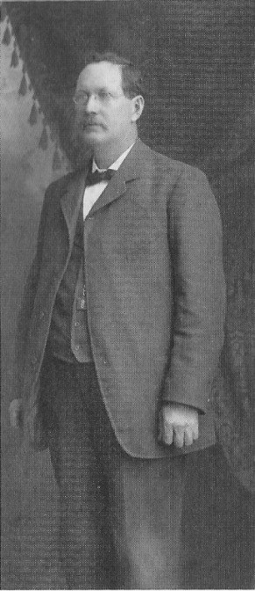
Harsha White, Los Angeles, circa 1900. Photo courtesy of Dr. James Ferguson

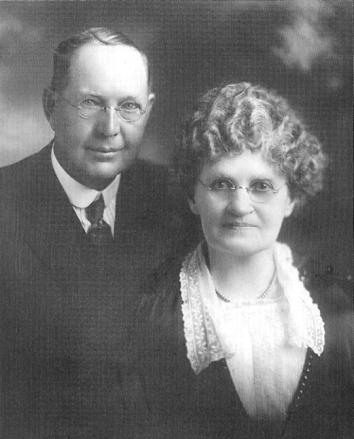
Harsha and Maude Yount, circa early 1920's. Photo courtesy of Joyce Yount Dangermond.

Ranch Life

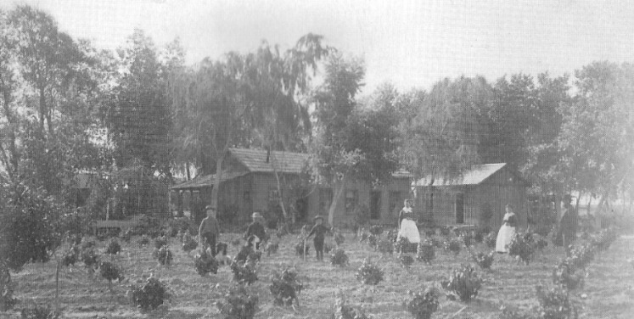
Manse Ranch vineyard with ranch house in background. 1889. Pictured are Joanna Yount Gardner and her three sons; others not identified. Photo courtesy of Dr. James Ferguson.

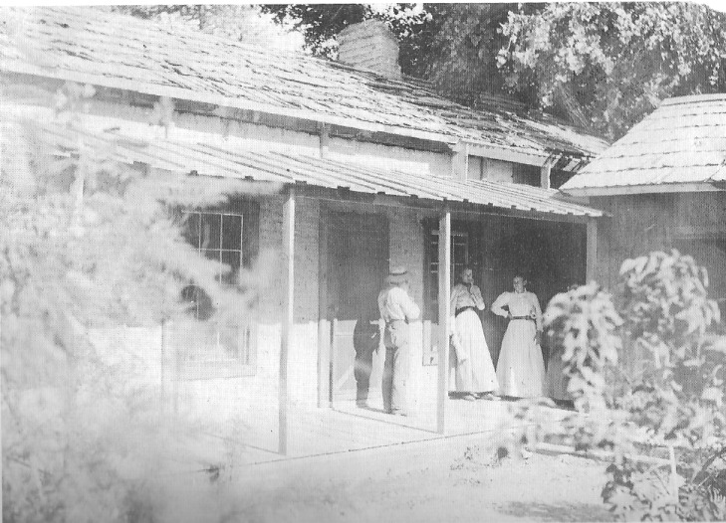
New back porch of Manse Ranch, circa 1890. From left, Clarence Neyman, Bessie Raymond, and Jennie Hellinger. Photo courtesy of Dr. James Ferguson.

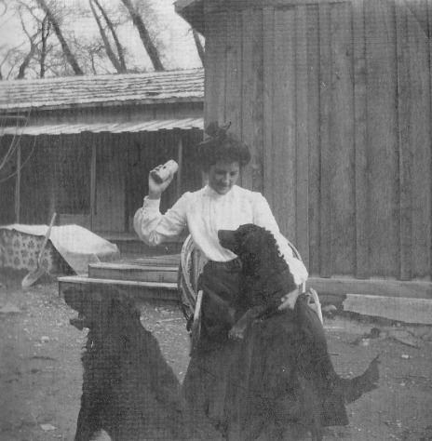
Della White Fisk and her dogs at the Manse Ranch, circa 1890. Photo courtesy of Dr. James Ferguson.

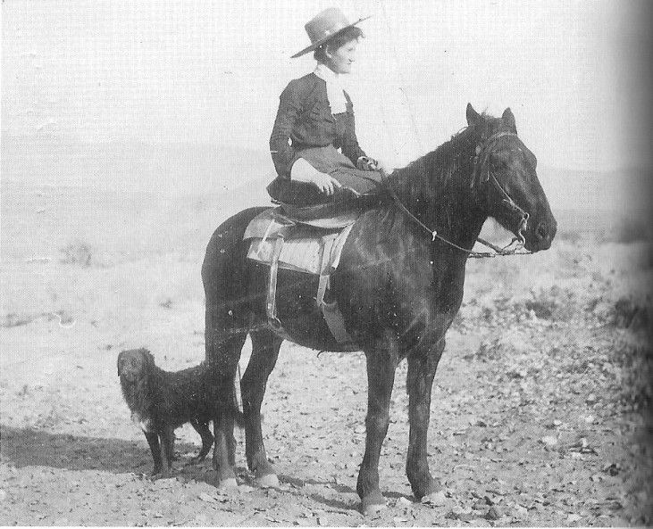
Della White Fisk riding sidesaddle, circa 1890. Photo courtesy of Joyce Yount Dangermond

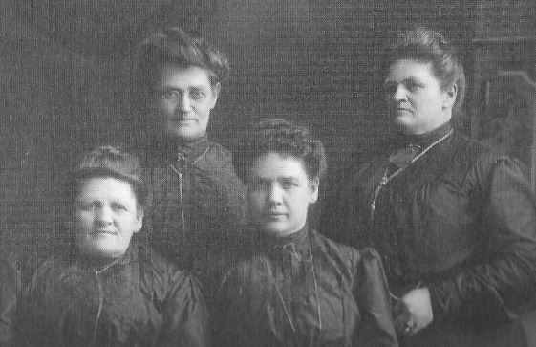
Yount sisters, circa 1895. From left, Laura, Maude, Fanny and Joanna (Annie). Nellie is not pictured. Photo courtesy of Dr. James Ferguson.

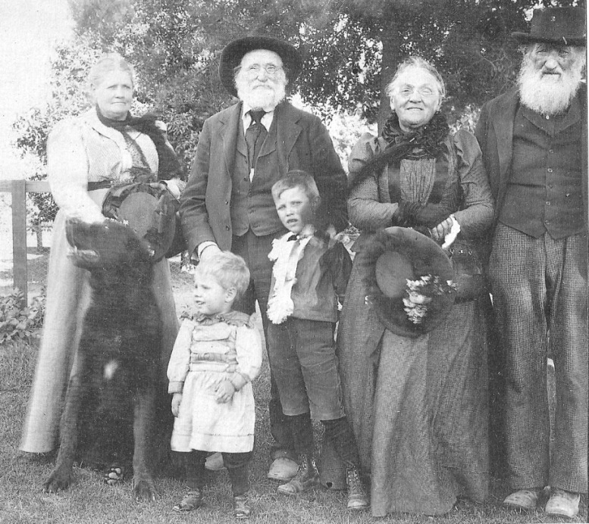
Left to right, Margaret and Joseph Yount, pictured with Grandmother and Grandfather Curtis, with Leroy and Mary's sons Bill and John, circa 1900. Photo courtesy of Joyce Yount Dangermond.

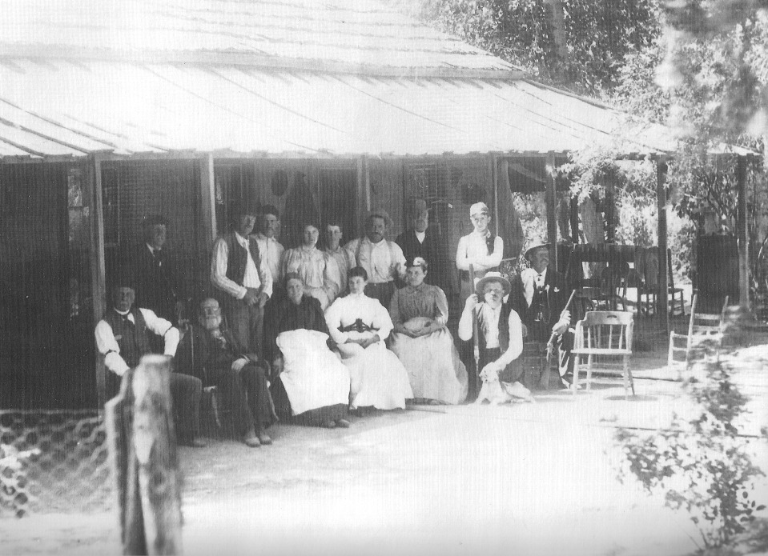
Gathering in front of the main house on the Manse Ranch, circa 1890. Joyce Yount Dangermond's mother, Dorothy Scott Yount, inscribed the following identification on the back of the photo: "Yount adobe at the Manse Ranch. From the left, Mr. Hays, he was born there. Swindler from Pittsburg, Grandfather and Grandmother Yount (Joseph & Margaret). Nellie Yount, Maude White and two strangers. Standing left to right, a stranger, Harsha White, John Yount, Della White, Clarence Gake, an orphan raised his brothers and sisters, raised by Sam Yount and two strangers." Photo courtesy of Joyce Yount Dangermond.

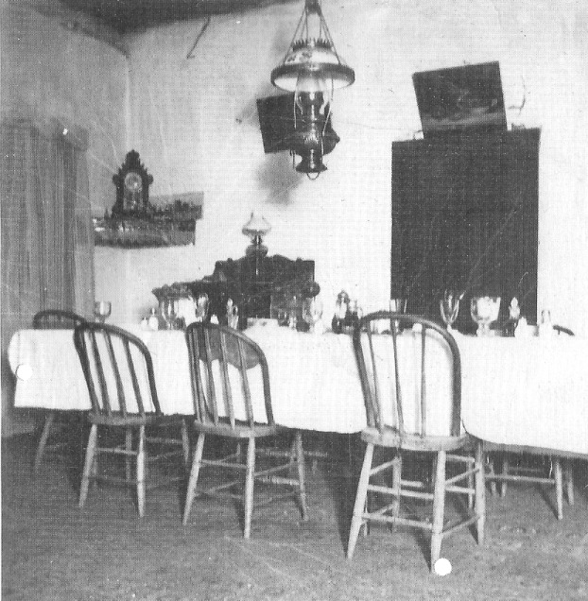
Dining room at the ranch, circa 1895. Photo courtesy of Dr. James Ferguson.

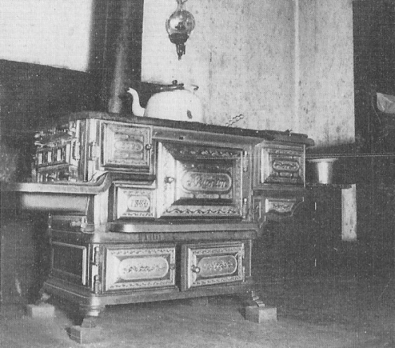
Kitchen range at the Manse Ranch, circa 1895

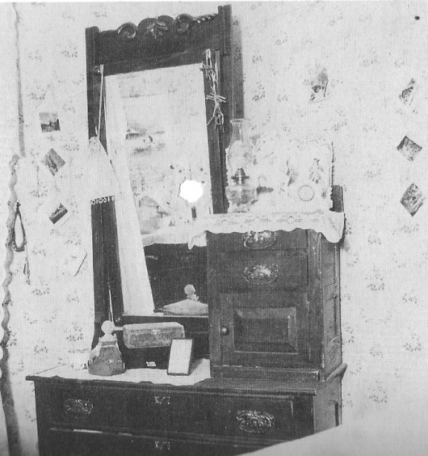
Dressing table in Della White's bedroom at the Manse Ranch, circa 1895. Photos courtesy of Dr. James Ferguson

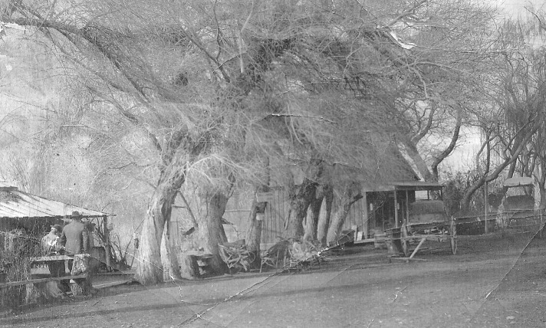
Manse Ranch front yard, circa 1900. Photo courtesy of Joyce Yount Dangermond.

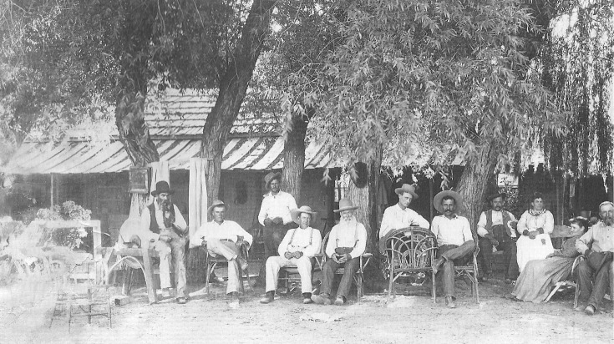
Group portrait at the Manse Ranch, circa 1900. Harsha White is fourth from the left; others unidentified. Photo courtesy of Joyce Yount Dangermond.

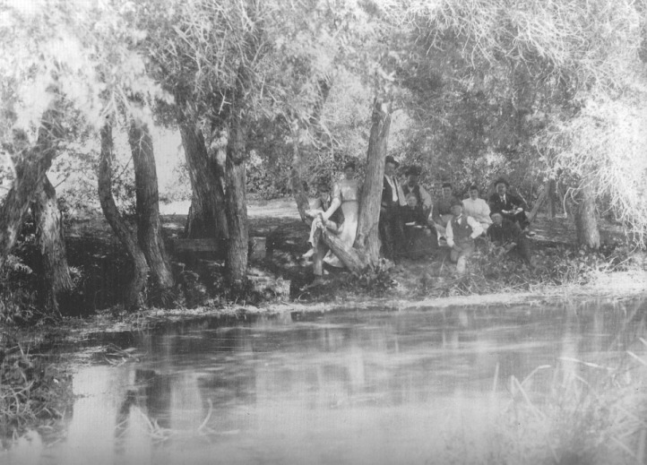
Pond formed by the smaller of the two big springs at the Manse Ranch, with people standing and sitting in the shade of the trees. Della White Fisk may be the woman standing beside the tree in the middle of the photo. Della was known for the fine manner in which she always dressed, having clothes to match every occasion and weather condition. This photo captures nicely the size of the pond and the luxuriant environment that the Manse Springs produced. Probably looking south. Photo courtesy of Joyce Yount Dangermond.

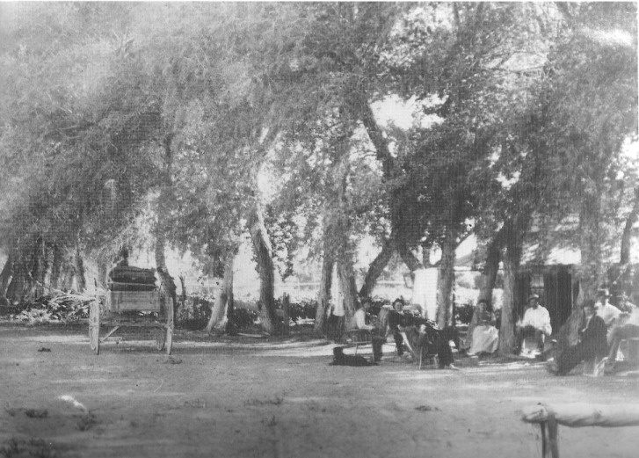
Unidentified persons sitting in front of the main house at the Manse Ranch, circa 1900. The area of the front yard with its many trees and a wagon is shown. Photo courtesy of Joyce Yount Dangermond.

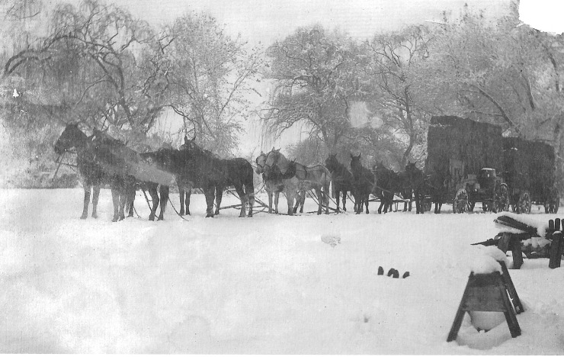
Ten horses pulling two wagons loaded with hay at the Manse Ranch during the winter with six inches of snow covering the ground, circa 1900. Several of the Yount boys were skilled teamsters, capable of handling twenty-horse or mule teams. Photo courtesy of Joyce Yount Dangermond.

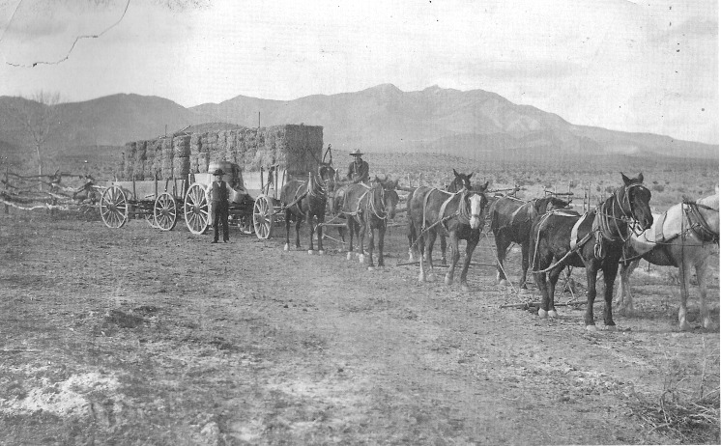
At least eight horses pulling two wagons loaded with hay near Manse Ranch, Pahrump Valley, with the Nopah Range in the background, circa 1900. the men are unidentified. Photo courtesy of Joyce Yount Dangermond.

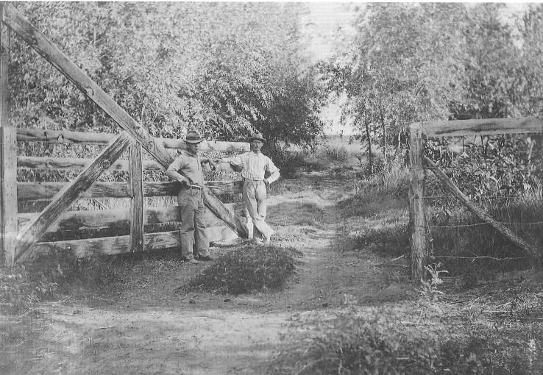
A gate and a fence at the Manse Ranch, circa 1905. Men unidentified. Photo courtesy of Joyce Yount Dangermond.

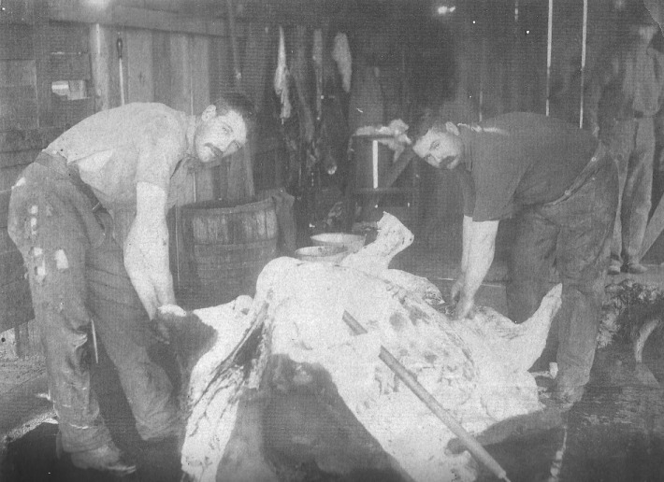
Unidentified young men (perhaps Leroy Yount on the left), butchering a cow on the Manse Ranch, circa 1900. Photo courtesy of Joyce Yount Dangermond.

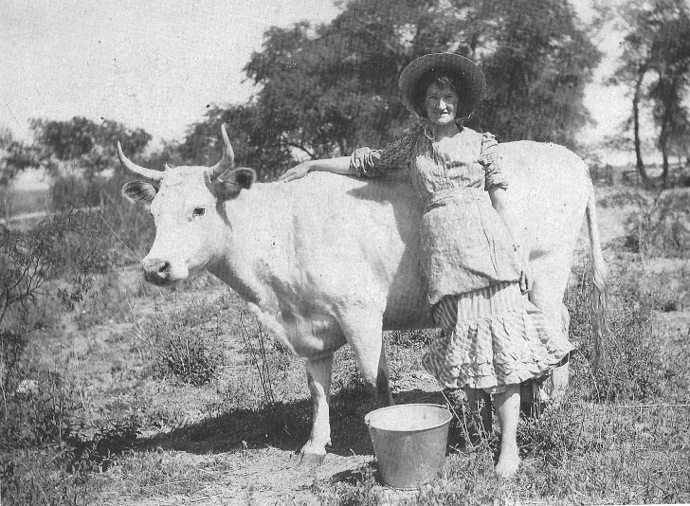
Della White Fisk pictured with milk cow on the Manse Ranch, circa 1900. Photo courtesy of Joyce Yount Dangermond.

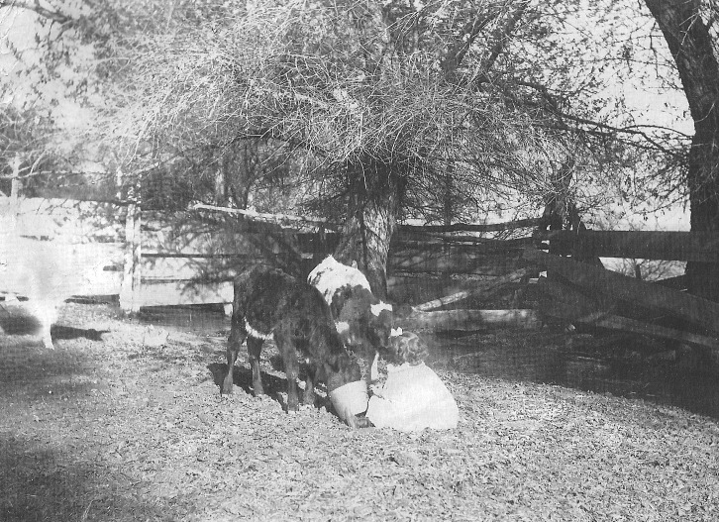
Young girl feeding two calves at the Manse Ranch prior to 1920. Girl is unidentified. Photo courtesy of Joyce Yount Dangermond.

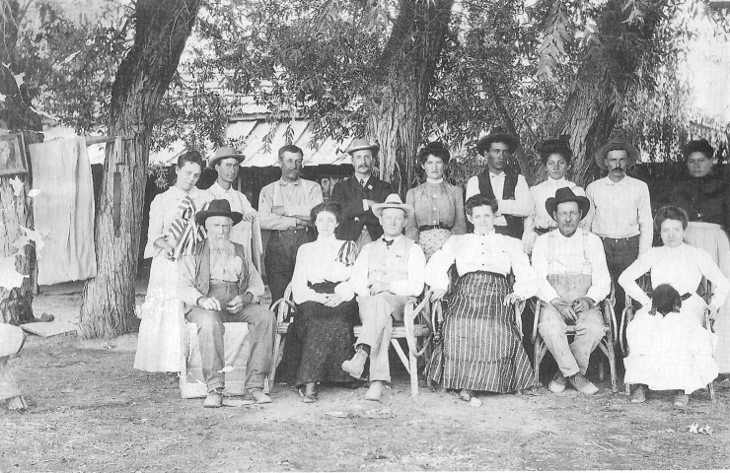
A Group portrait at the manse Ranch, circa 1900. The woman seated in the middle in striped skirt is Maude Yount White; beside her in the black hat is Harsha White. According to one copy of this print a Mr. Clark is seated on the far left. Others unidentified. Photo courtesy of Joyce Yount Dangermond.

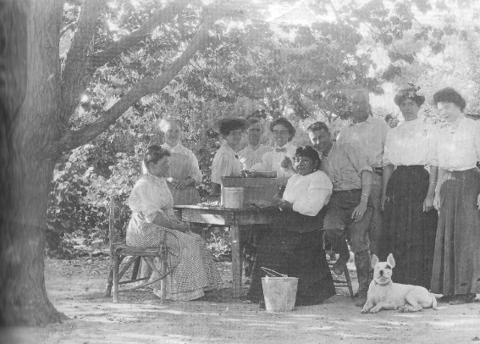
Gathering out of doors at the Manse Ranch, circa 1900. No one pictured is identified. The seated woman with the dark skirt appears to be Native American. Photo courtesy of Joyce Yount Dangermond.

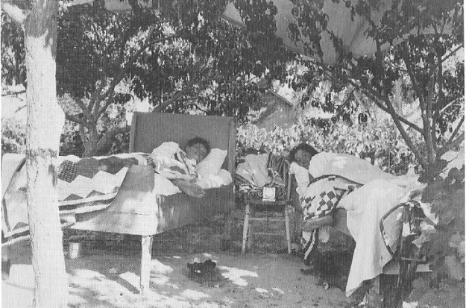
Sleeping outdoors under the trees at the Manse Ranch, circa 1900. Note the handmade quilts. One of the women is likely Della White Fisk. Photo courtesy of San Bernardino County Museum.

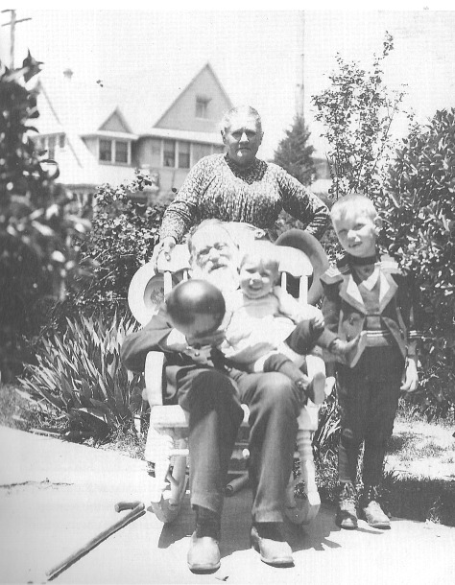
Joseph and Margaret Yount in the driveway to their home in San Bernardino, with grandsons John, standing, and Bill, circa 1900. Photo courtesy of Joyce Yount Dangermond.

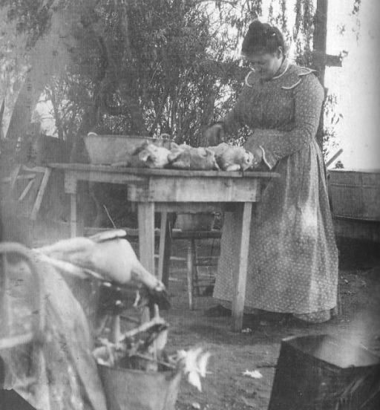
Maude Yount White preparing chickens and goose for dinner, Manse Ranch, circa 1900. Photo courtesy of San Bernardino County Museum.

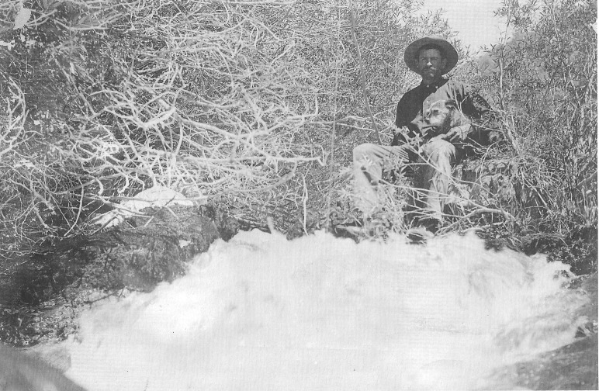
John Yount beside a stream in the Charleston Mountains, circa 1900. John Yount was the only one of the Yount children who spent his entire adult life in the Pahrump Valley. Photo courtesy of Joyce Yount Dangermond.

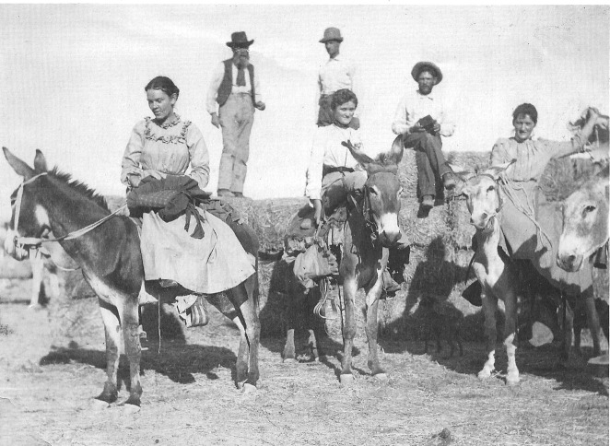
Burros and sidesaddle riders, Manse Ranch , circa 1900. Della White Fisk is on the far right. Photo courtesy of Joyce Yount Dangermond.

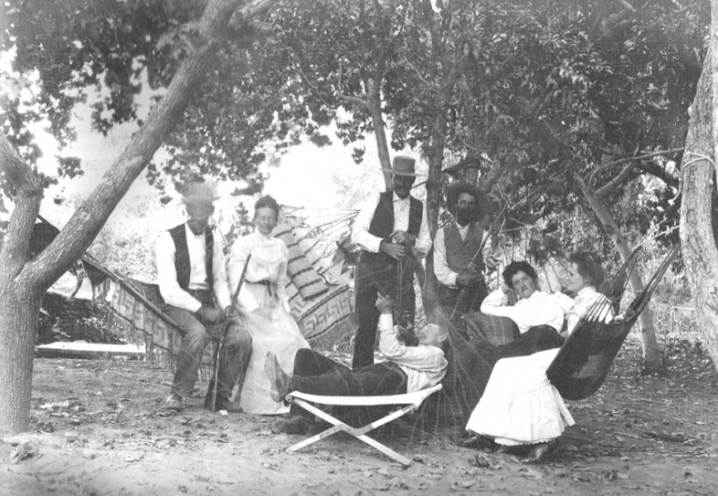
Under the peach trees at the Manse Ranch, circa 1905. Della White Fisk is second from right. Photo courtesy of San Bernardino County Museum

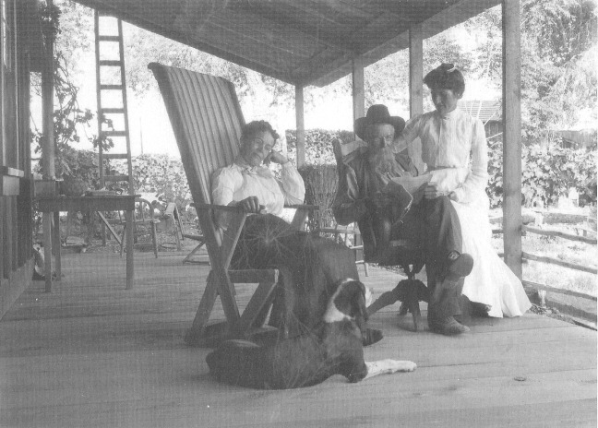
Relaxing on the porch. Photo courtesy of Dr. James Ferguson.

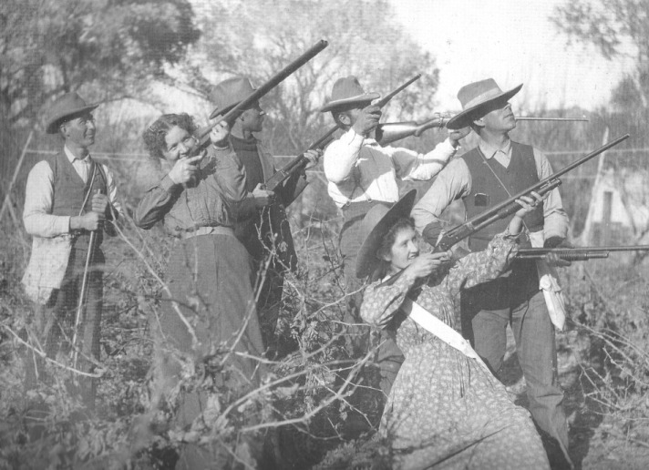
Hunting on the Manse Ranch, circa 1905. Della White Fisk is at front right. Photo courtesy of San Bernardino County Museum

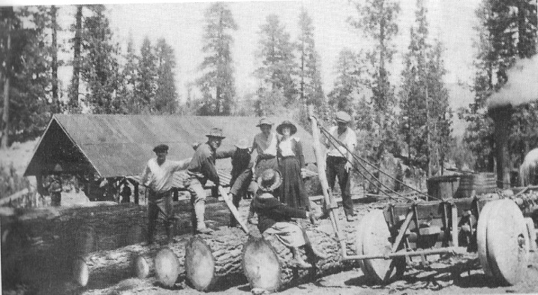
Sawmill and logs belonging to Harsha White and partners, circa 1905. Photo courtesy of Joyce Yount Dangermond

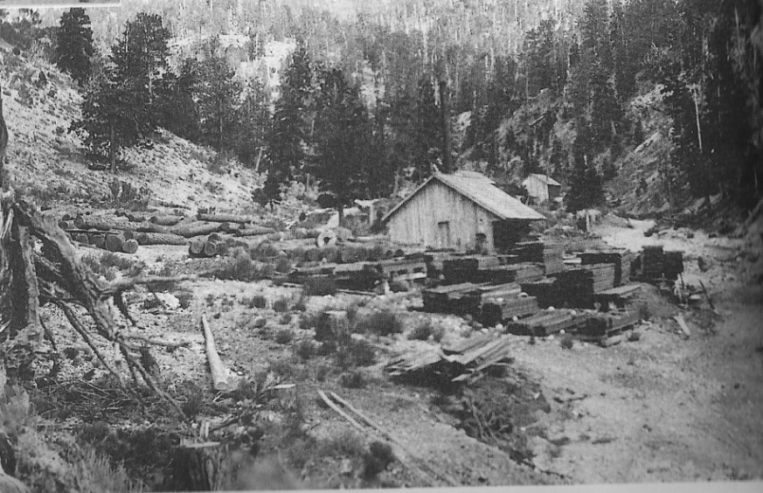
A view of the sawmill belonging to the Young family and partners, located in the Spring Mountains east of the Manse Ranch, circa 1905. Photo courtesy of Joyce Yount Dangermond.

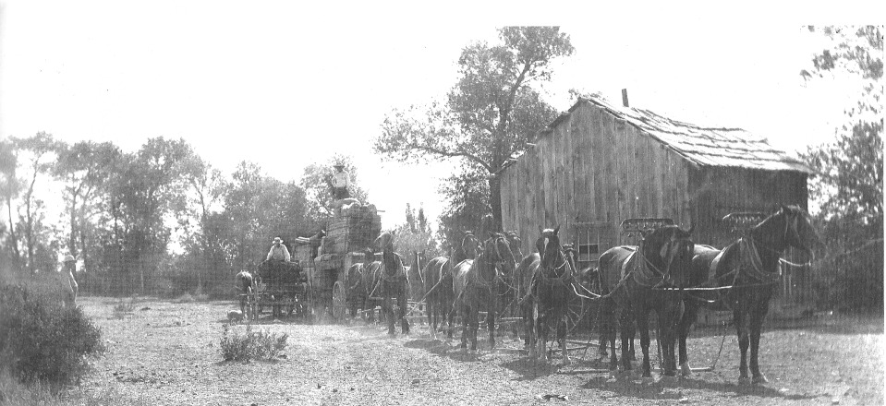
Ten horses pulling two wagons stacked high with lumber, Manse Ranch, circa 1905. The lumber was probably produced at the Yount family's sawmill in the Spring Mountains above Pahrump Valley. Photo courtesy of San Bernardino County Museum

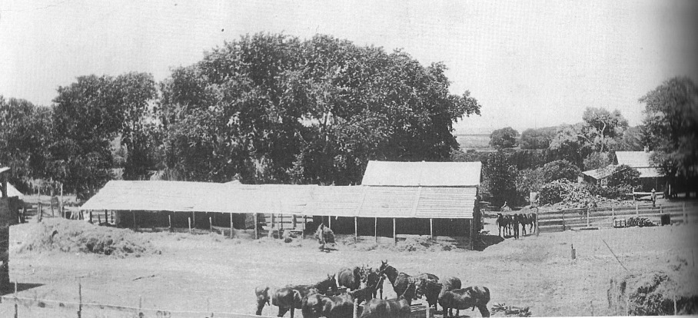
A view of the Manse Ranch showing corrals, barns, livestock, and outbuildings and a dwelling circa 1910. the photo appears to be taken looking west. Photo courtesy of Joyce Yount Dangermond.

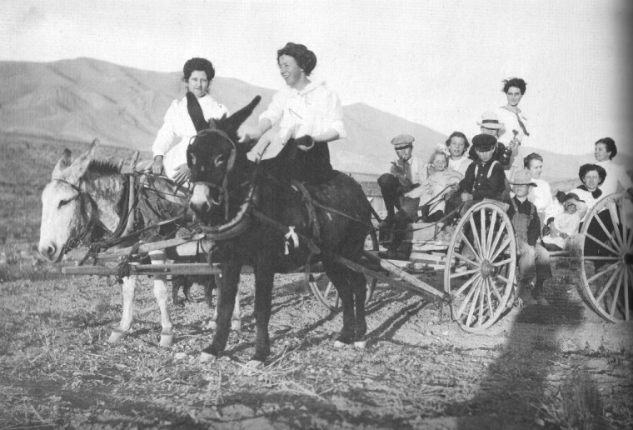
Jolly party near Manse Ranch, circa 1910. Photo courtesy of San Bernardino County Museum

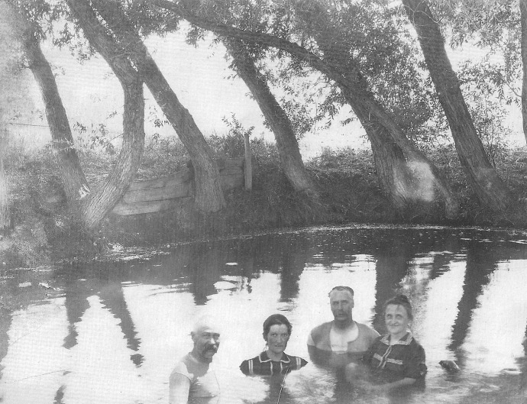
A big pool fed by one of the two large springs at the Manse Ranch. Della White Fisk, second from left, is among those enjoying a refreshing dip in the waters; probably Harsha White is to her left, circa 1910. Photo courtesy of Joyce Yount Dangermond.

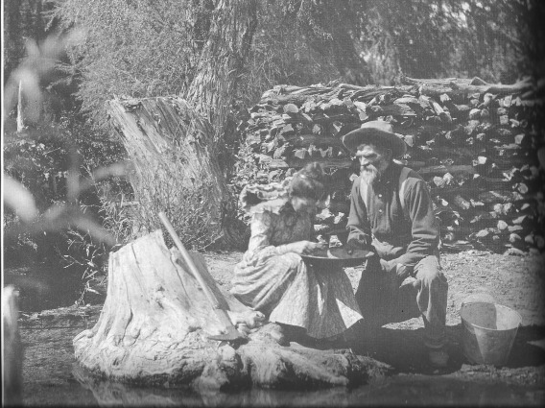
Della White Fisk and her uncle John Yount panning for gold. manse Ranch, circa 1910. Photo courtesy of San Bernardino County Museum

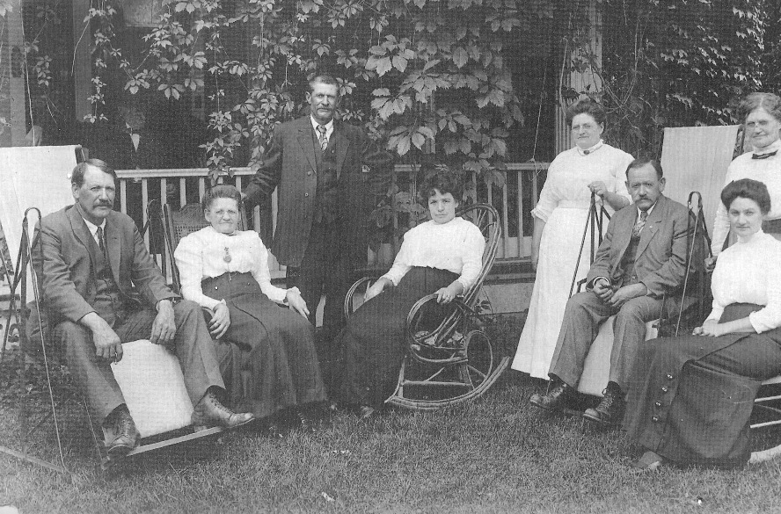
Children of Joseph and Margaret Yount at their home in San Bernardino, California, August 1911. From left: Leroy, Laura, John (standing), Fanny, Annie, Sam Nellie, and Maude. Photo courtesy of Joyce Yount Dangermond.

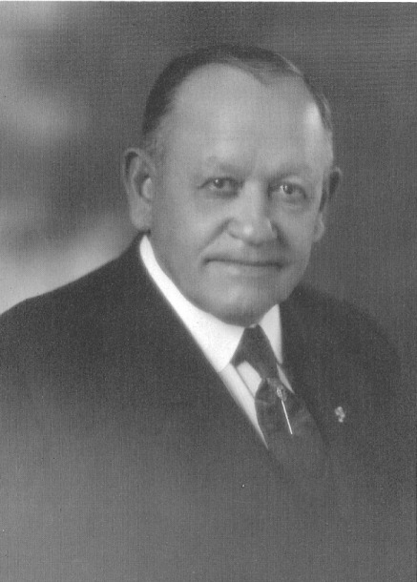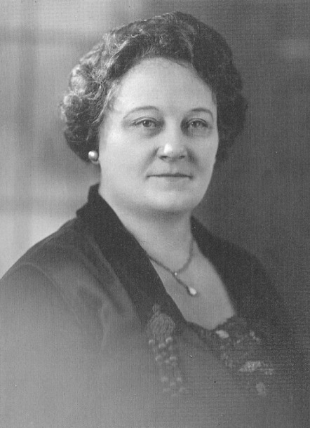
Sam Yount and wife, Emma, circa 1920. It is said she had an adopted son when she married Yount. Photos courtesy of Joyce Yount Dangermond.

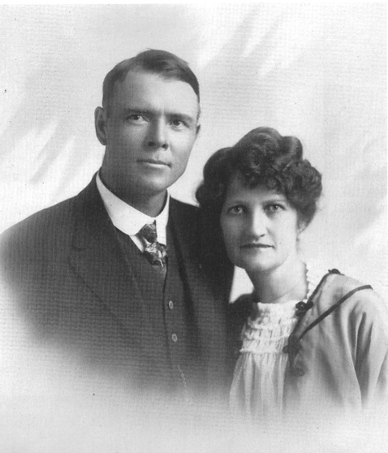
Jim Fisk and Della White Fisk, circa 1920. Photo courtesy of Joyce Yount Dangermond.

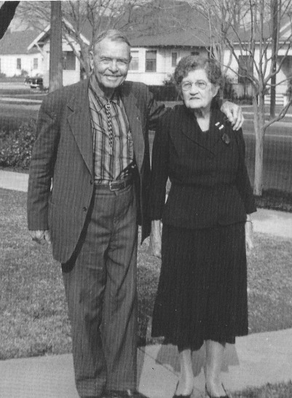
Jim Fisk and Della white Fisk in front of their home in San Bernardino, California, circa 1950. Photo courtesy of Joyce Yount Dangermond.

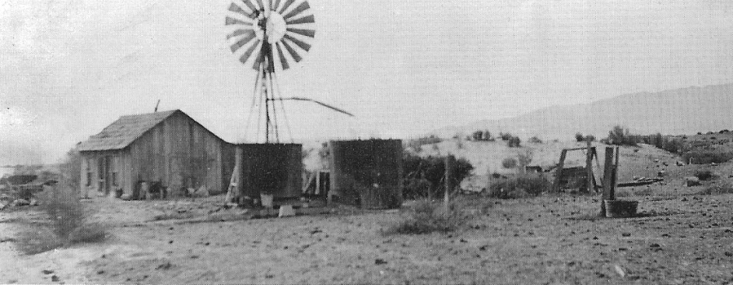
A view of John B. Yount's house on his ranch, which he called Charleston View Ranch. His ranch was located about 10 miles south of the Manse Ranch in Pahrump Valley. the date of this photo is unknown but prior to 1937, perhaps 1920's. Photo courtesy of Joyce Yount Dangermond.

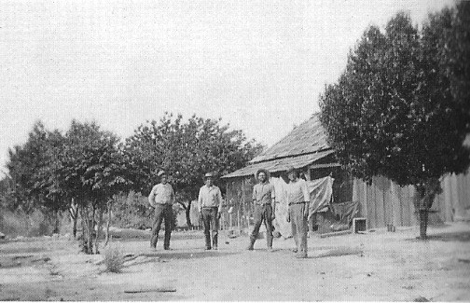
John Yount's ranch, men unidentified. Upon John Yount's death in 1937, Roland Wiley, a Las Vegas attorney, purchased the ranch. Wiley called it the Hidden Hills Ranch because the ranch house and outbuildings were concealed among low lying hills in that part of Pahrump Valley. the structure seen in this photo was remodeled and is shown with Ronald Wiley in front of it. The date of this photo is unknown but certainly prior to 1937. Photo courtesy of Joyce Yount Dangermond.

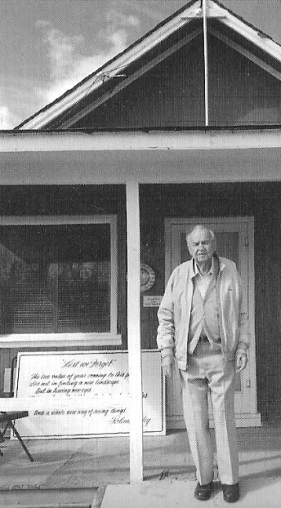
Roland Wiley in front of the cabin originally owned by John Yount at the Hidden Hills Ranch. Circa 1990. Photo courtesy of Joyce Yount Dangermond.

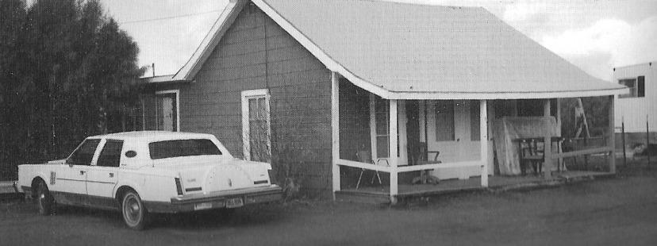
Another view of the cabin. Circa 1990 - Photo courtesy of Joyce Yount Dangermond

